Network Layer: Internet Protocol

In this section, we discuss internetworking, connecting networks together to make an internetwork or an internet..

20-1 INTERNETWORKING

Topics discussed in this section:
Need for Network Layer Internet as a Datagram Network
Internet as a Connectionless Network

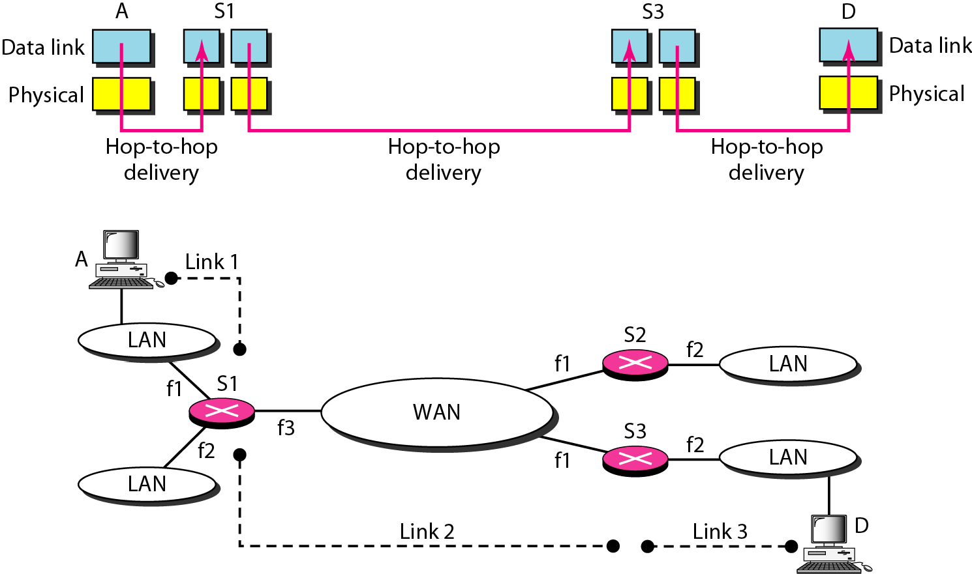

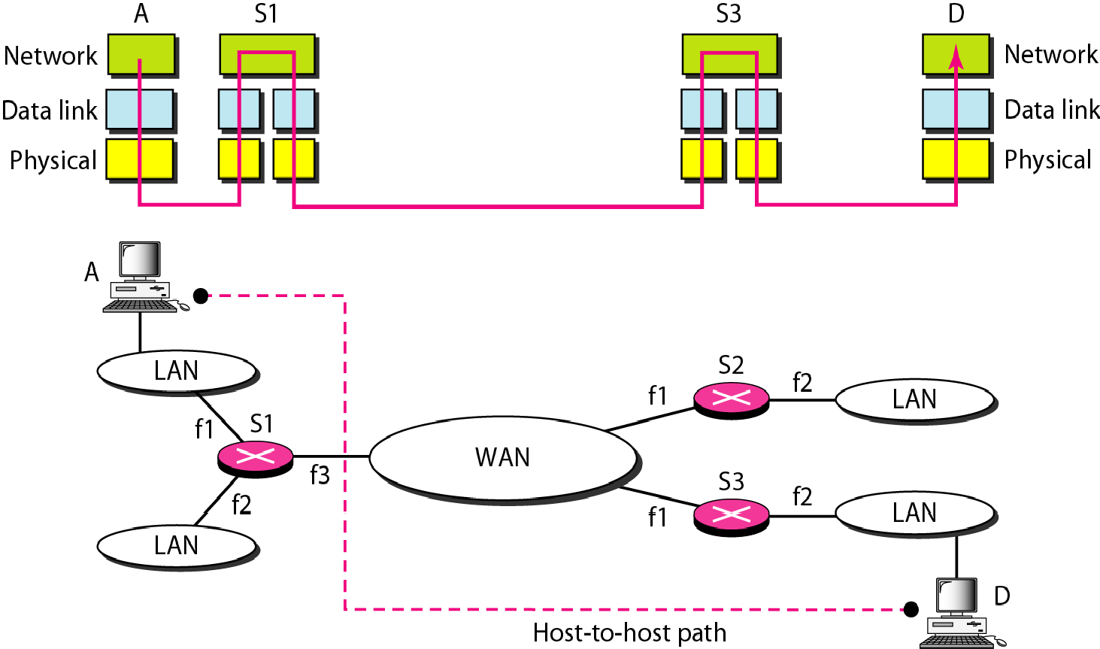

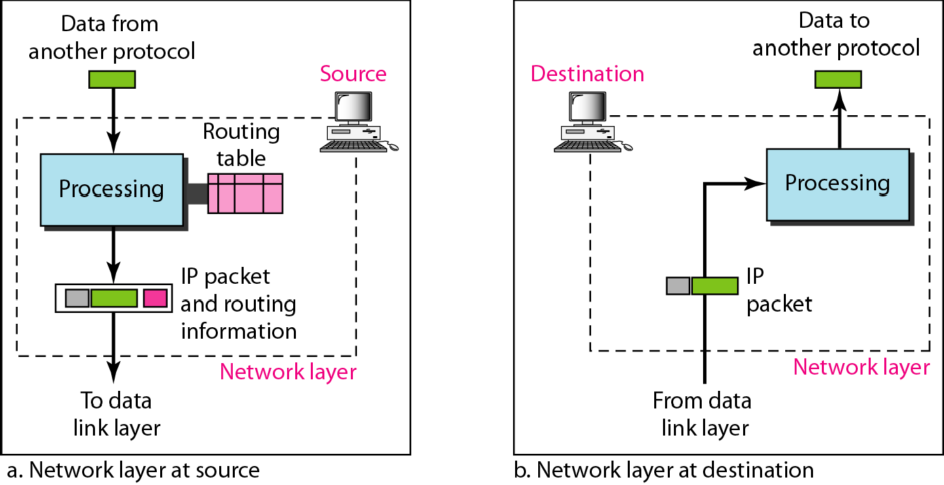

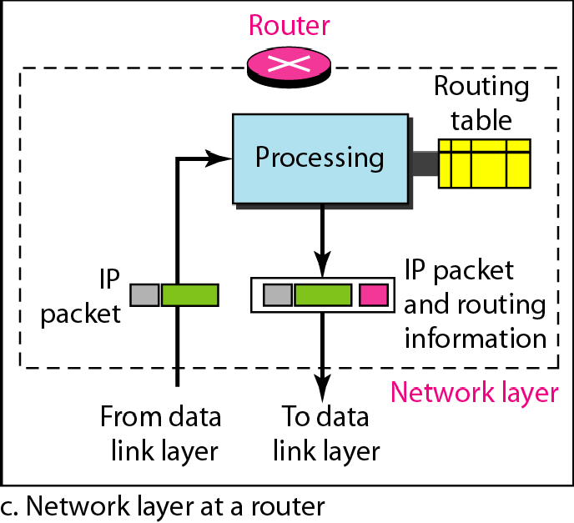

Note

Switching at the network layer in the Internet uses the datagram approach to packet switching.

Note

Communication at the network layer in the Internet is connectionless.

The Internet Protocol version 4 (IPv4) is the delivery mechanism used by the TCP/IP protocols.

20-2 IPv4

Topics discussed in this section:
Datagram Fragmentation Checksum Options

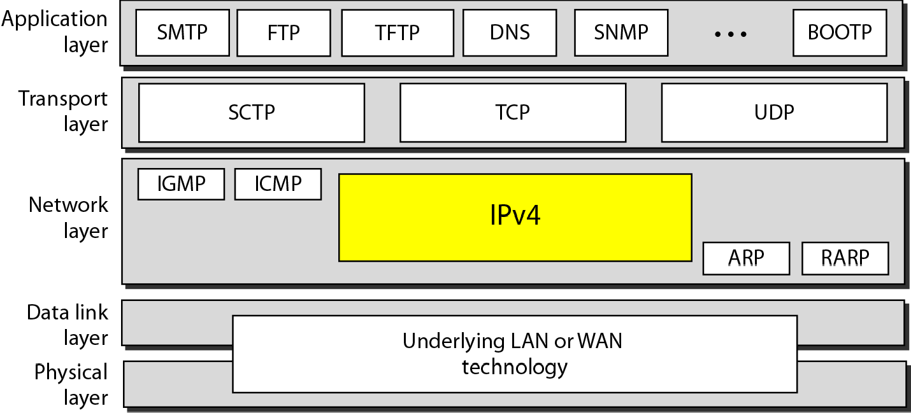

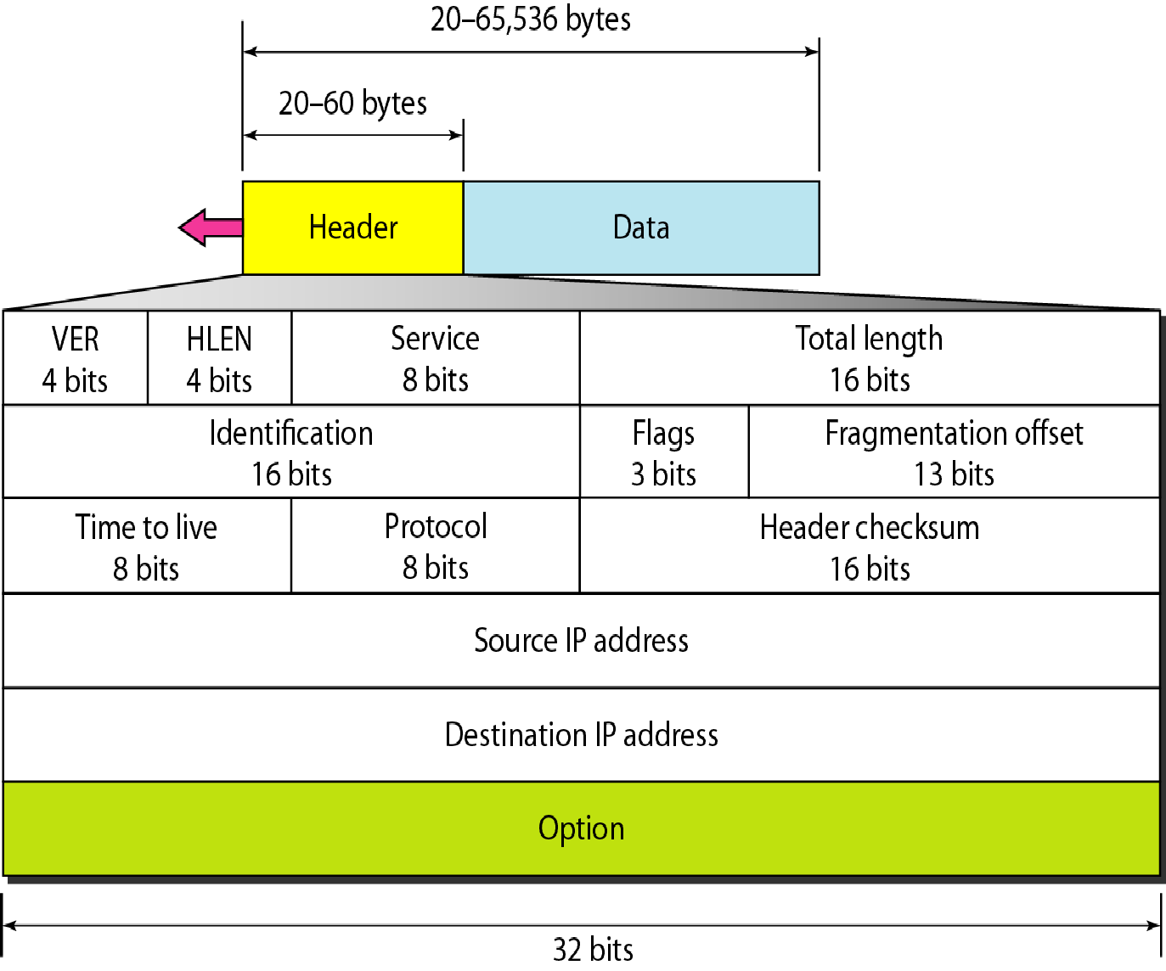

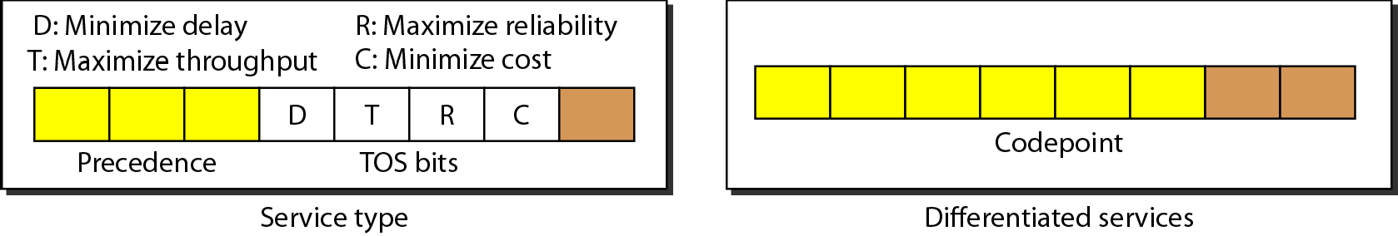

Note

The precedence subfield was part of version 4, but never used.

Table 20.1 Types of service
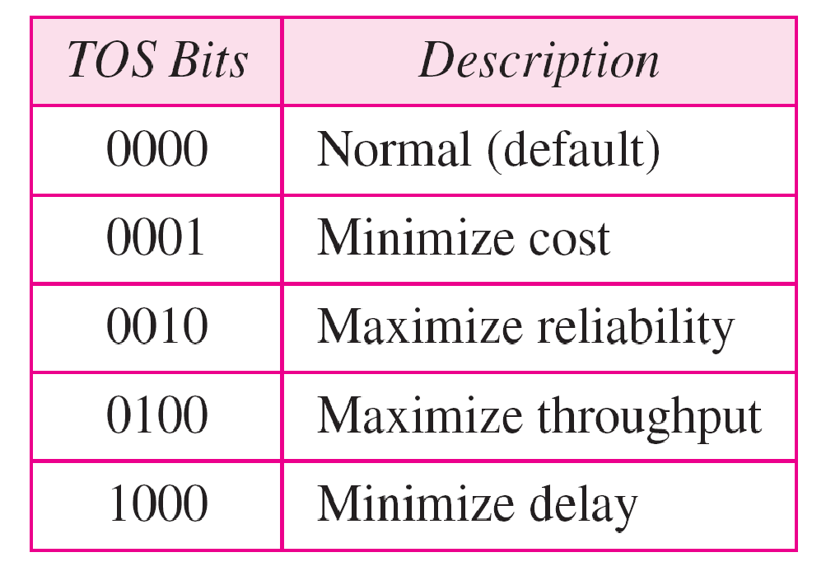

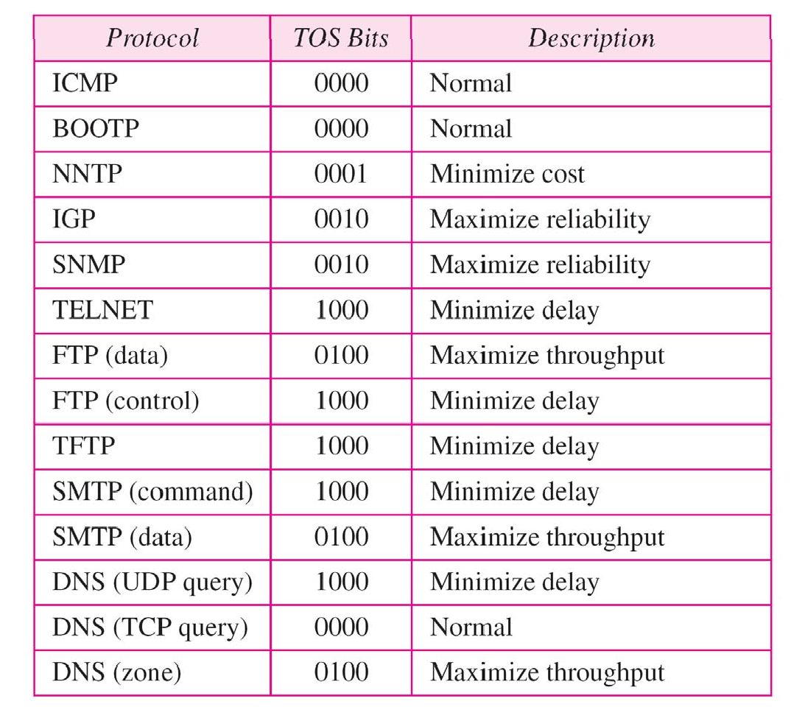
Table 20.2 Default types of service

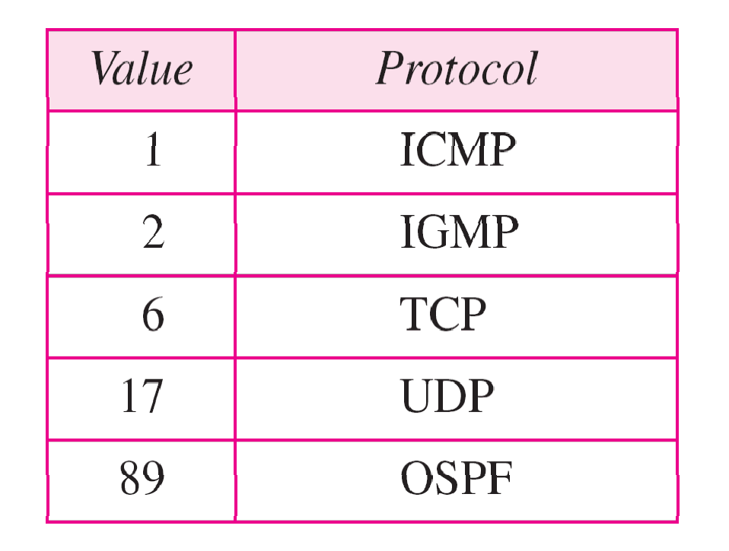Table 20.3 Values for codepoints

Note

The total length field defines the total length of the datagram including the header.

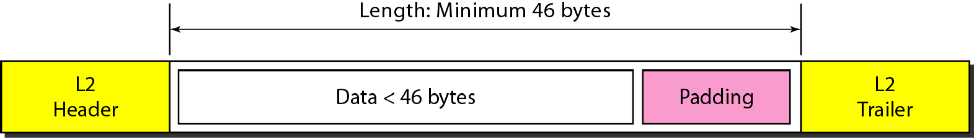

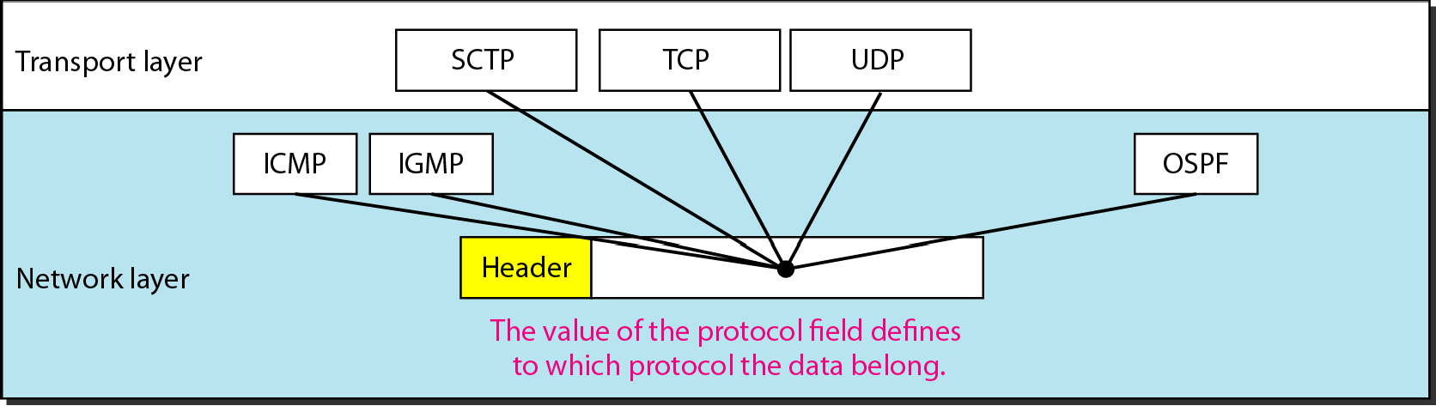

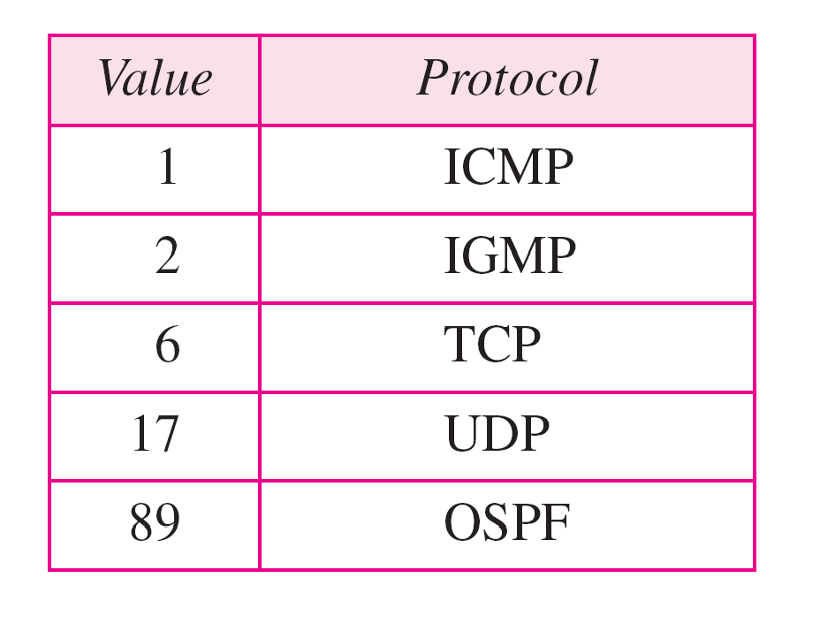Table 20.4 Protocol values

An IPv4 packet has arrived with the first 8 bits as shown:
01000010
The receiver discards the packet. Why?

Solution
There is an error in this packet. The 4 leftmost bits (0100)

show the version,
which is correct.
The next 4 bits (0010)

show an invalid header length (2 × 4 = 8). The minimum number of bytes in the header must be 20 The packet has been corrupted in transmission.

In an IPv4 packet, the value of HLEN is 1000 in binary. How many bytes of options are being carried by this packet?

Solution
The HLEN value is 8, which means the total number of
bytes in the header is 8 × 4, or 32 bytes The first 20 bytes
are the base header, the next 12 bytes are the options.

In an IPv4 packet, the value of HLEN is 5, and the value of the total length field is 0x0028. How many bytes of data are being carried by this packet?

Solution
The HLEN value is 5, which means the total number of
bytes in the header is 5 × 4, or 20 bytes (no options) The
total length is 40 bytes, which means the packet is carrying 20 bytes of data (40 − 20)

An IPv4 packet has arrived with the first few hexadecimal digits as shown.
0x45000028000100000102 . . .
How many hops can this packet travel before being dropped? The data belong to what upper-layer protocol?

Solution
To find the time-to-live field, we skip 8 bytes. The time-to- live field is the ninth byte, which is 01. This means the packet can travel only one hop. The protocol field is the next byte (02), which means that the upper-layer protocol is IGMP.

Figure 20.9 Maximum transfer unit (MTU)

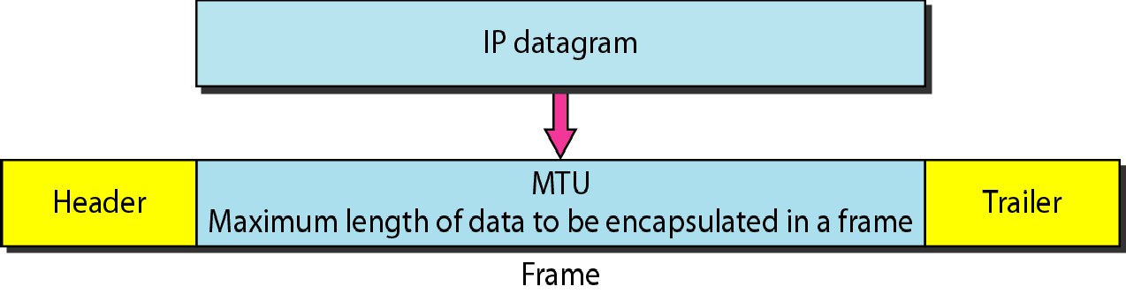

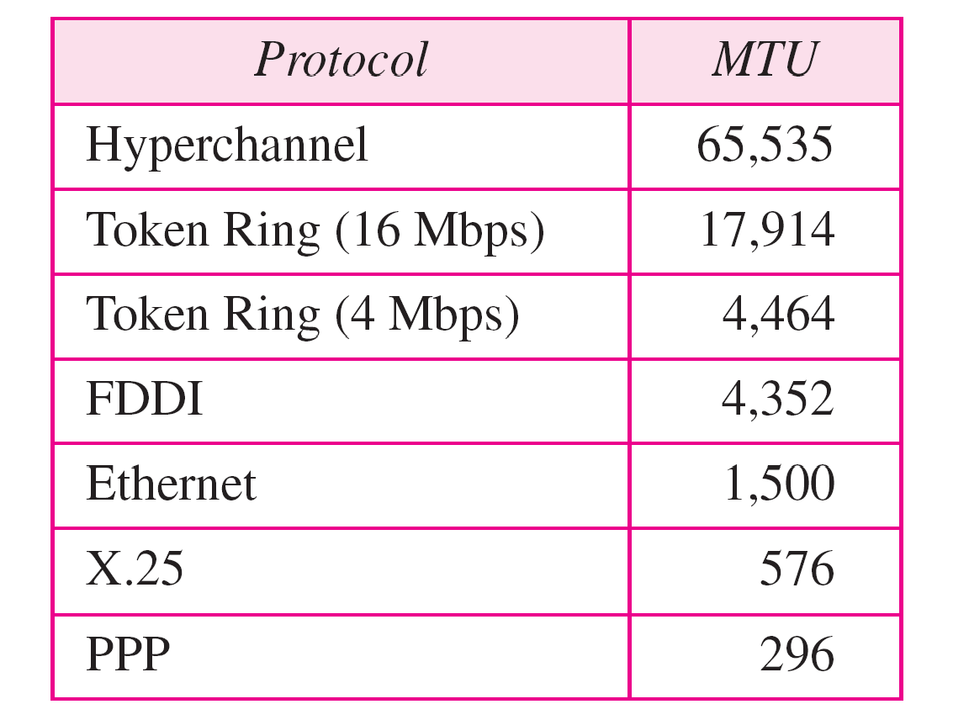
Table 20.5 MTUs for some networks

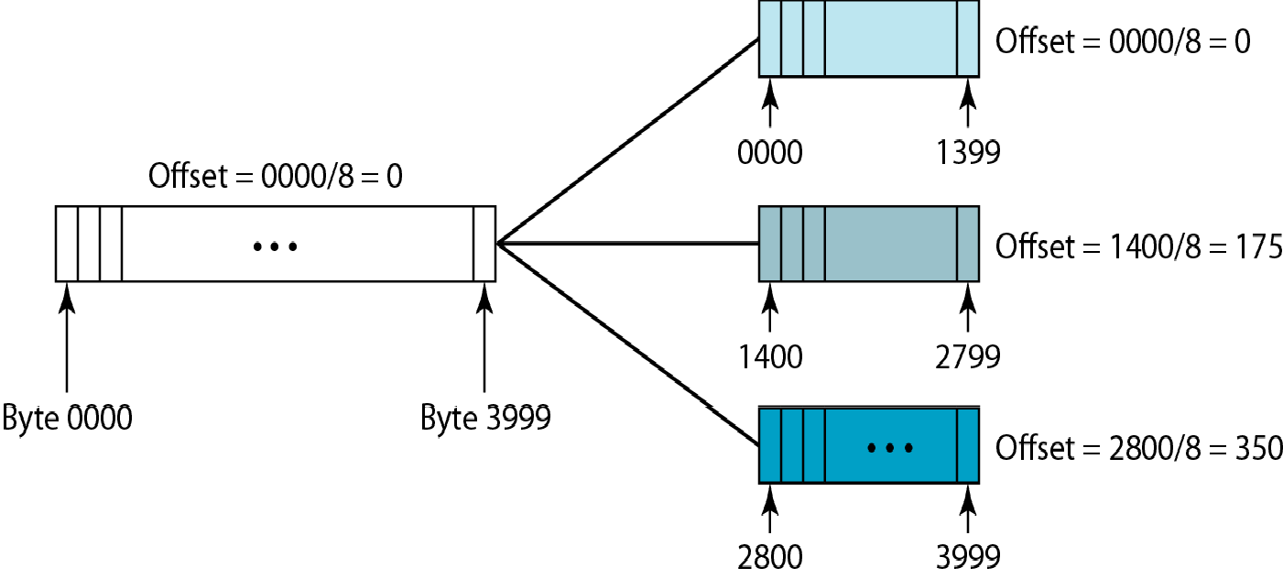

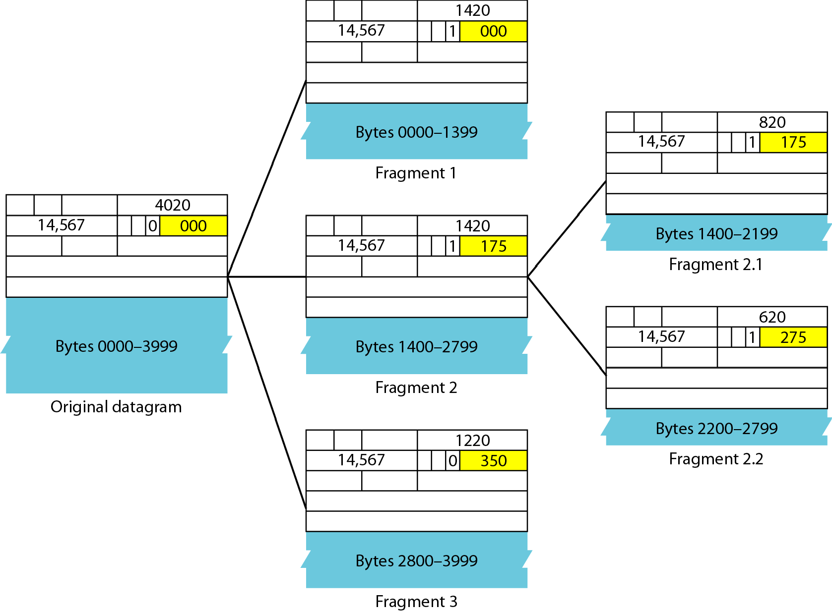

A packet has arrived with an M bit value of 0. Is this the first fragment, the last fragment, or a middle fragment? Do we know if the packet was fragmented?

Solution
If the M bit is 0, it means that there are no more
fragments; the fragment is the last one However, we
cannot say if the original packet was fragmented or not. A non-fragmented packet is considered the last fragment

A packet has arrived with an M bit value of 1. Is this the first fragment, the last fragment, or a middle fragment? Do we know if the packet was fragmented?

Solution
If the M bit is 1, it means that there is at least one more fragment This fragment can be the first one or a middle one, but not the last one. We don’t know if it is the first one or a middle one; we need more information (the value of the fragmentation offset).

A packet has arrived with an M bit value of 1 and a fragmentation offset value of 0. Is this the first fragment, the last fragment, or a middle fragment?

Solution
Because the M bit is 1, it is either the first fragment or a

middle one Because the offset value is 0, fragment.
it is the first

A packet has arrived in which the offset value is 100. What is the number of the first byte? Do we know the number of the last byte?

Solution
To find the number of the first byte, we multiply the offset value by 8 This means that the first byte number is 800 We cannot determine the number of the last byte unless we know the length.

A packet has arrived in which the offset value is 100, the value of HLEN is 5, and the value of the total length field is 100. What are the numbers of the first byte and the last byte?
Solution
The first byte number is 100 × 8 = 800. The total length is

100 bytes,
and the header length is 20 bytes (5 × 4),
which

means that there are 80 bytes in this datagram. If the first
byte number is 800, the last byte number must be 879

Figure 20.13 shows an example of a checksum calculation for an IPv4 header without options. The header is divided into 16-bit sections. All the sections are added and the sum is complemented. The result is inserted in the checksum field.

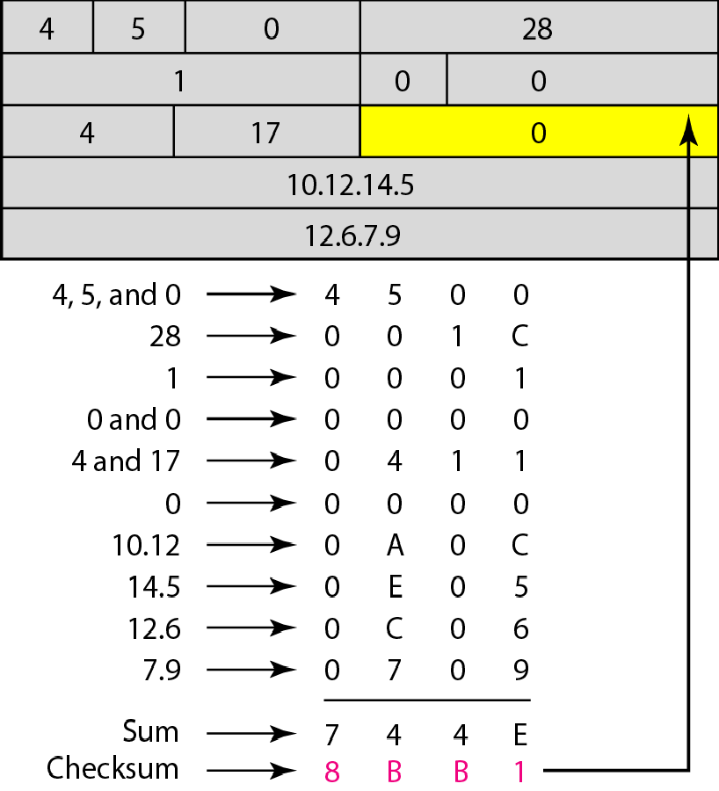

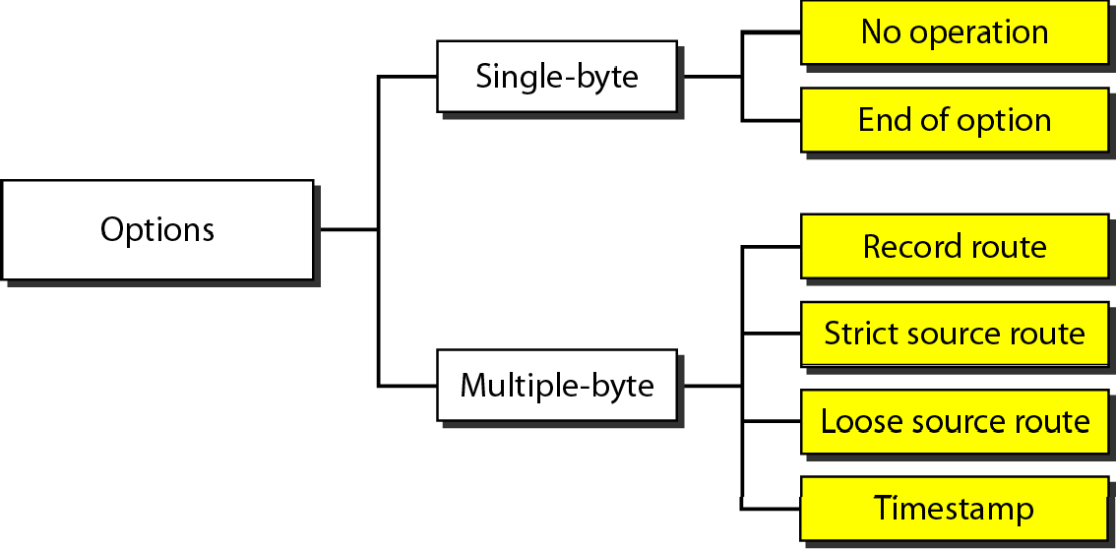

The network layer protocol in the TCP/IP protocol suite is currently IPv4. Although IPv4 is well designed, data communication has evolved since the inception of IPv4 in the 1970s. IPv4 has some deficiencies that make it unsuitable for the fast-growing Internet..

20-3 IPv6

Topics discussed in this section:
Advantages Packet Format Extension Headers

20.38

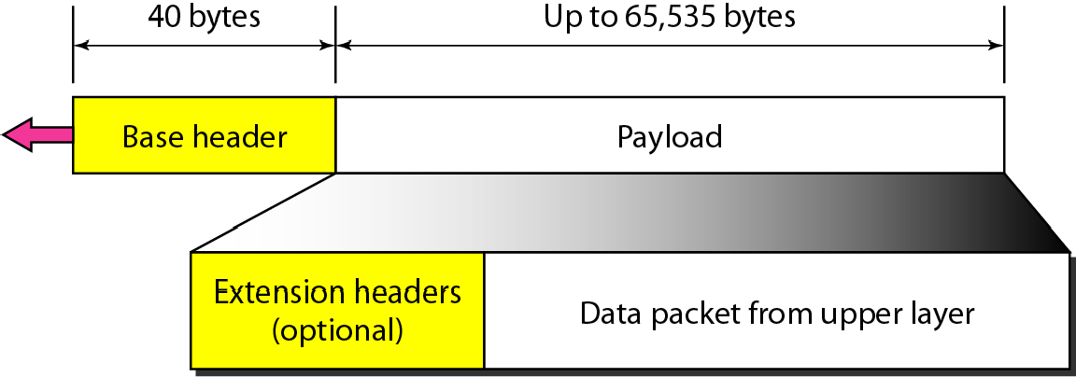

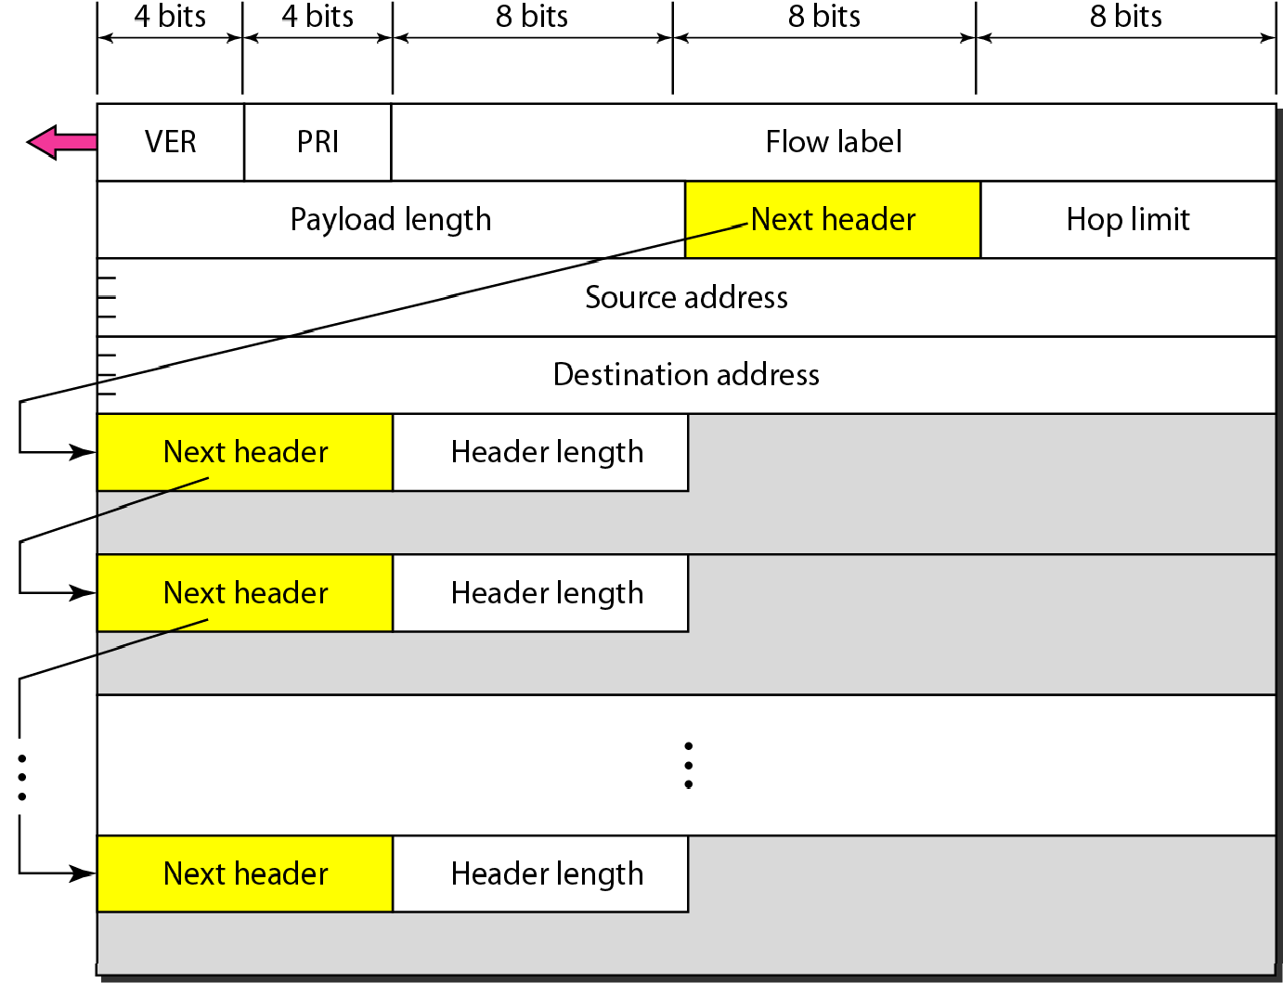

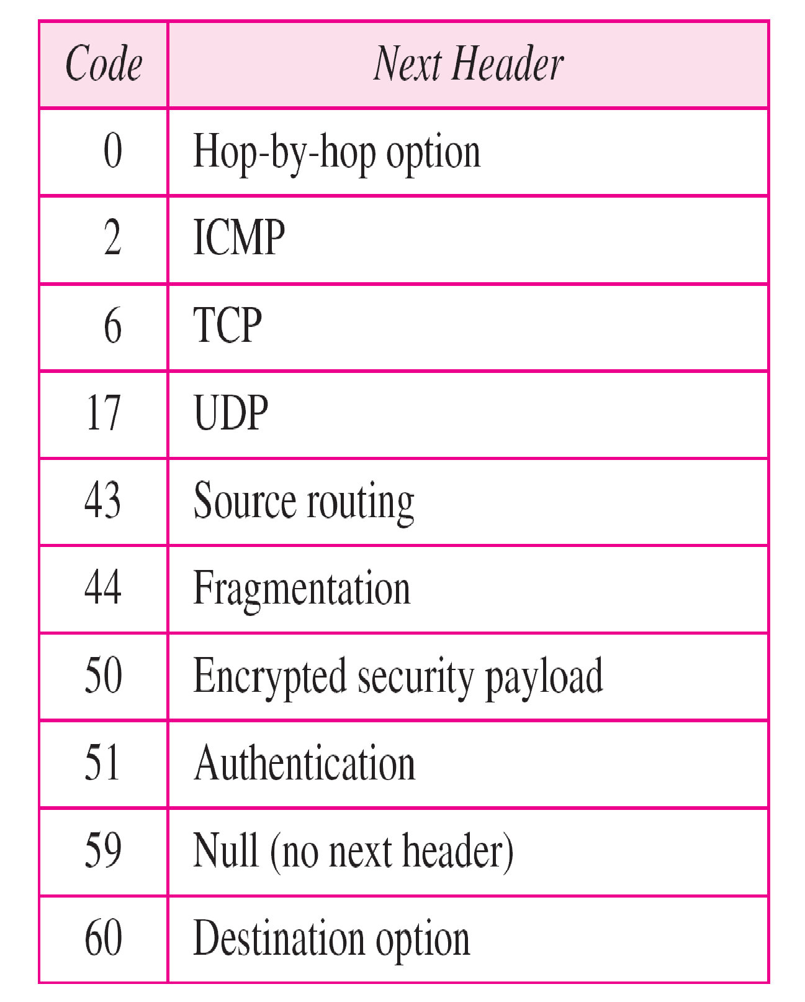
Table 20.6 Next header codes for IPv6

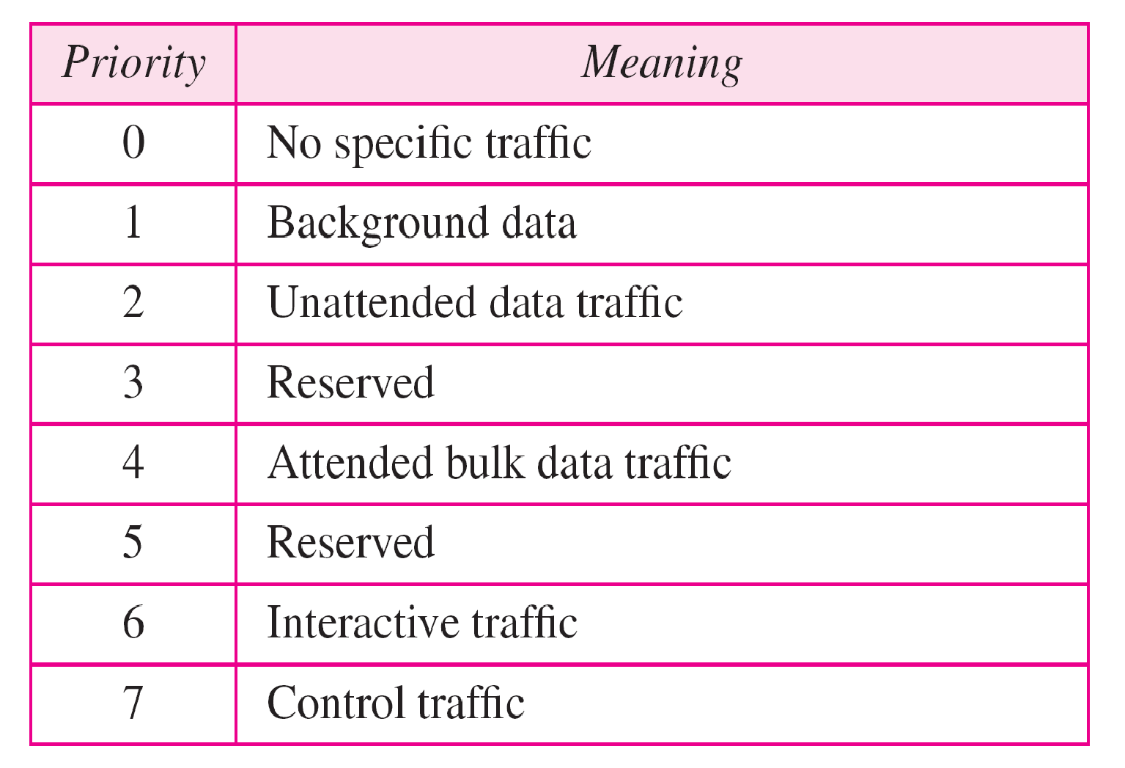

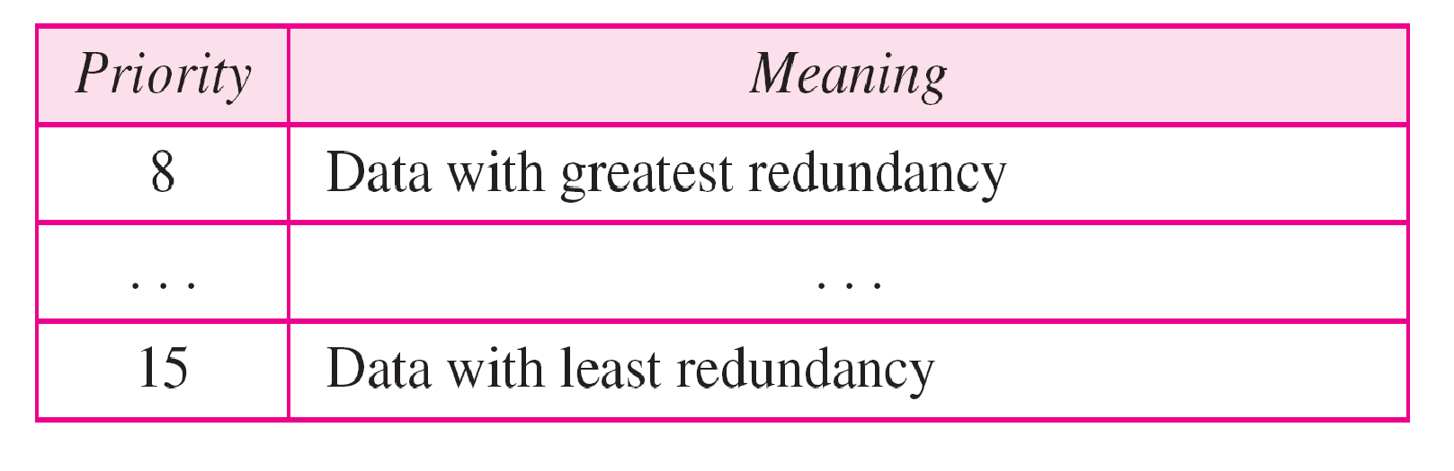

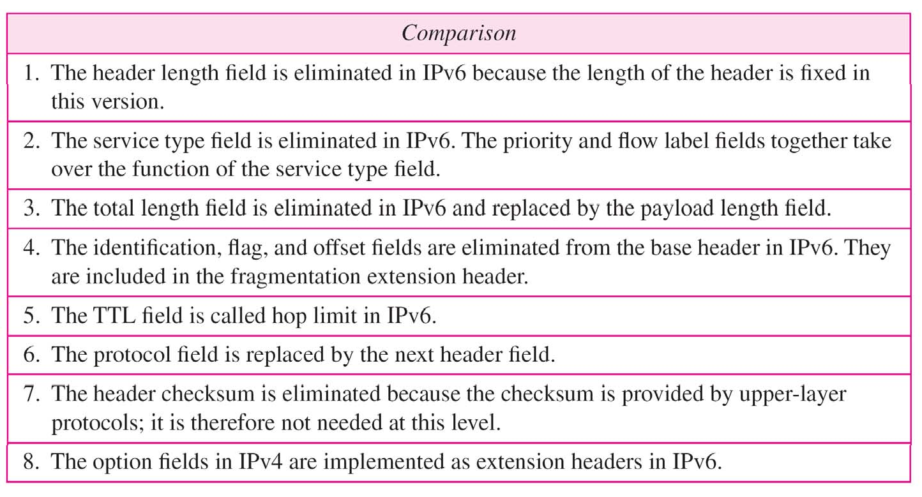

Figure 20.17 Extension header types

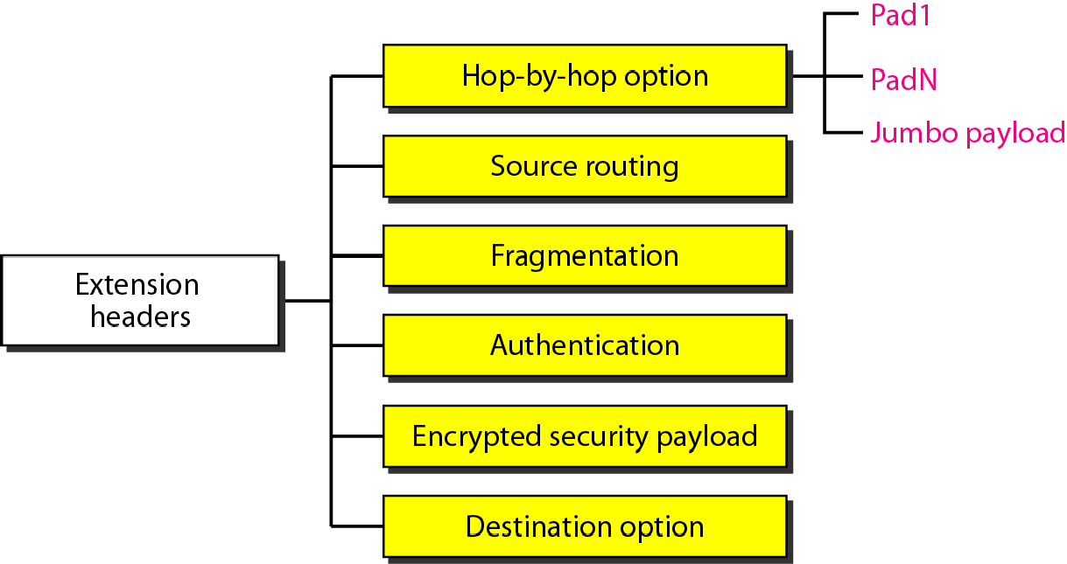

Table 20.10 Comparison between IPv4 options and IPv6 extension headers
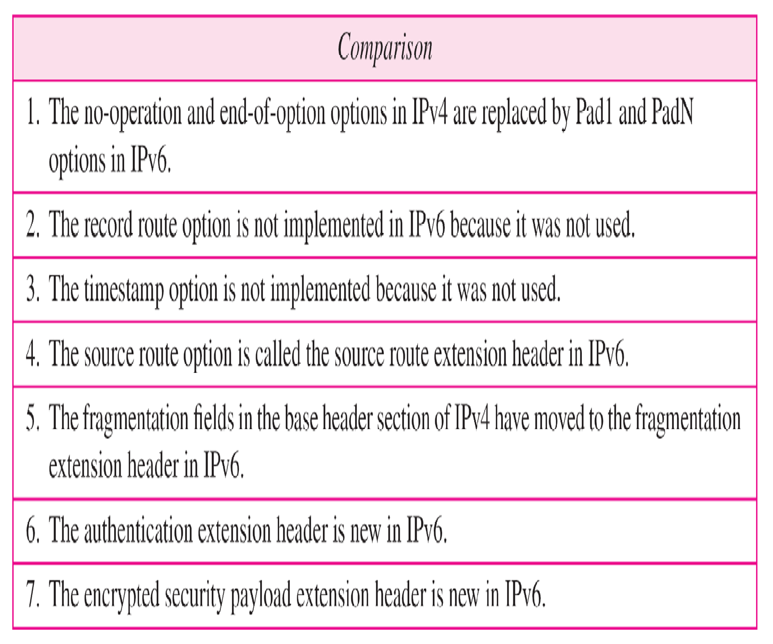

Because of the huge number of systems on the Internet, the transition from IPv4 to IPv6 cannot happen suddenly.. It takes a considerable amount of time before every system in the Internet can move from IPv4 to IPv6.. The transition must be smooth to prevent any problems between IPv4 and IPv6 systems.

20-4 TRANSITION FROM IPv4 TO IPv6

Topics discussed in this section:
Dual Stack Tunneling
Header Translation

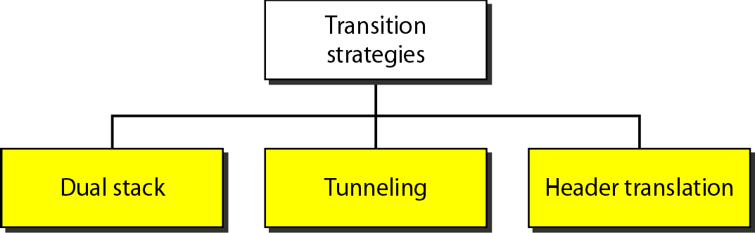

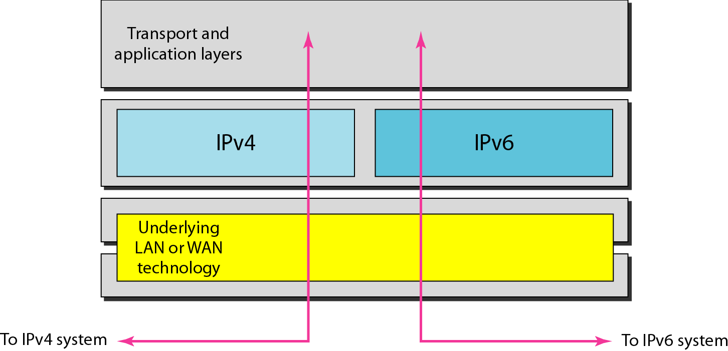

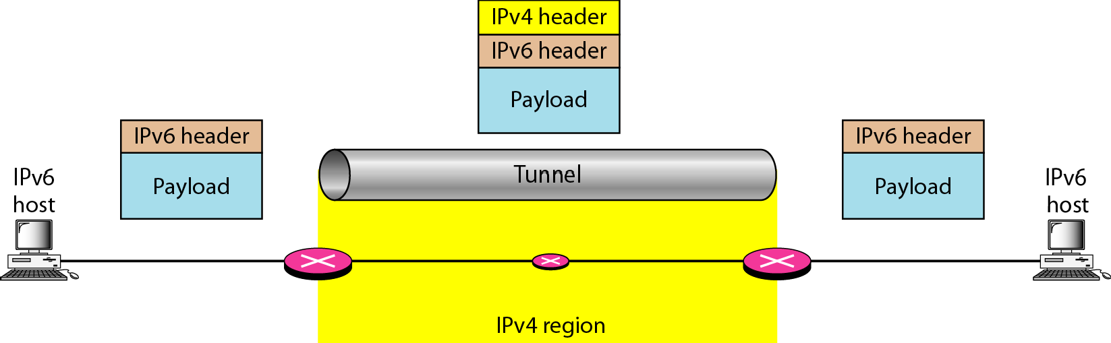

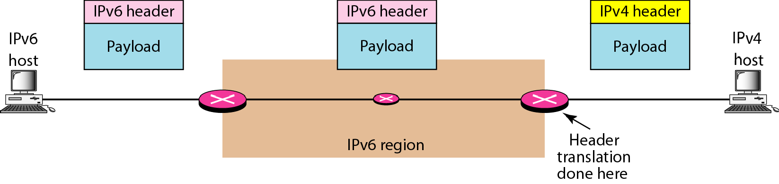

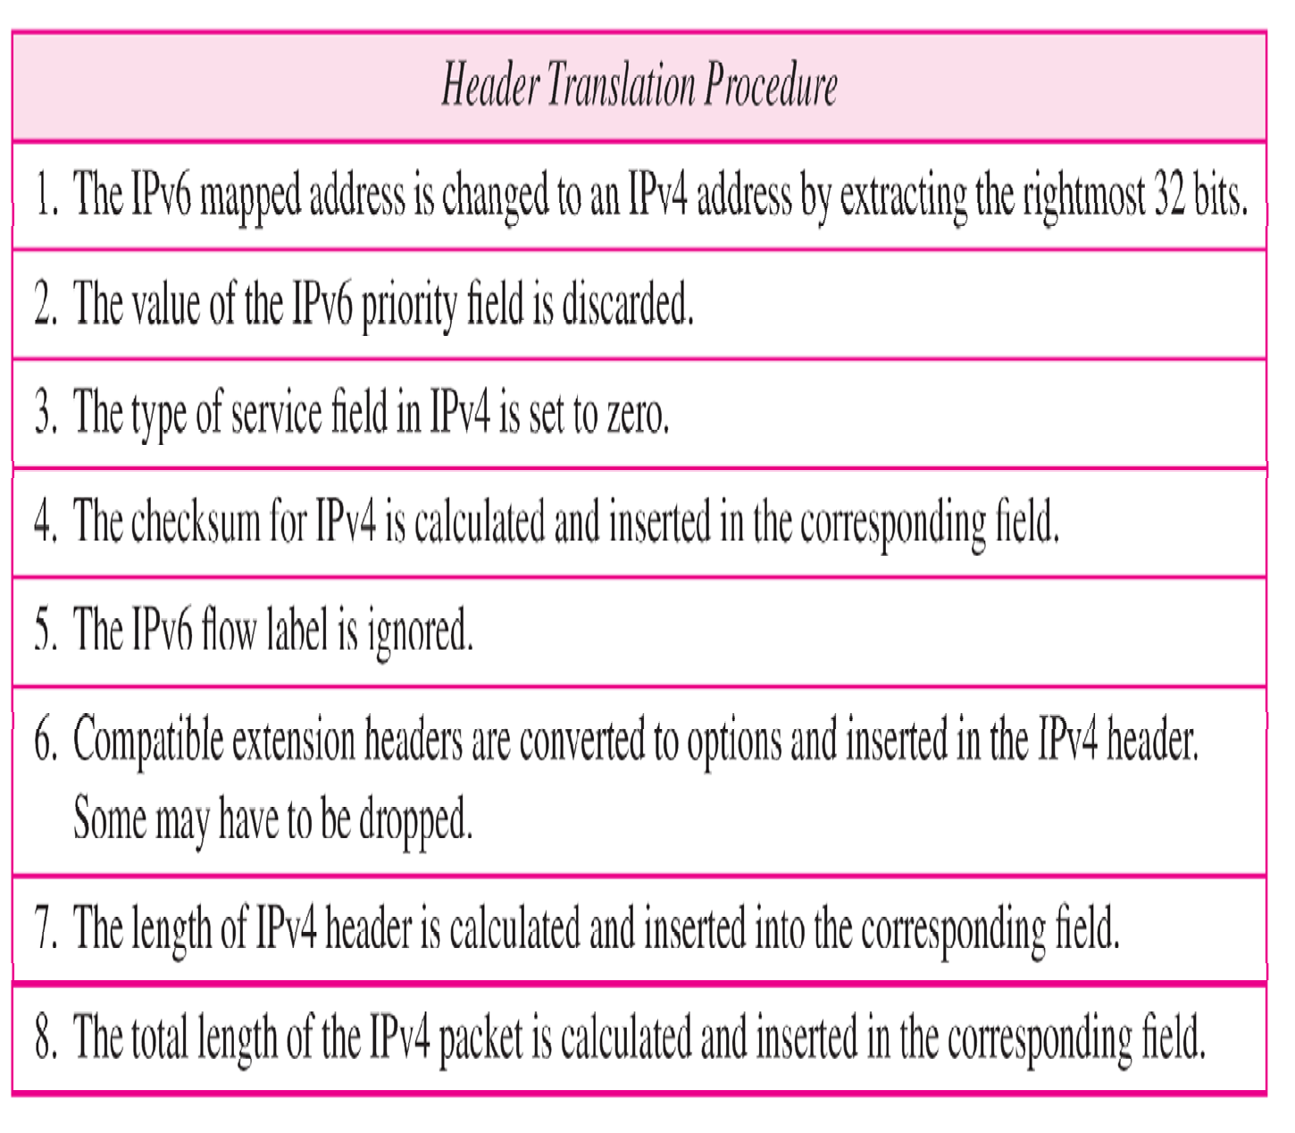Table 20.11 Header translation

