UNIT-IV
MULTIMEDIA ARCHITECTURE
Multimedia encompasses a large variety of technologies and integration of multiple architectures interacting in real time. All of these multimedia capabilities must integrate with the standard user interfaces such as Microsoft Windows.
The following figure describes the architecture of a multimedia workstation environment. In this diagram.
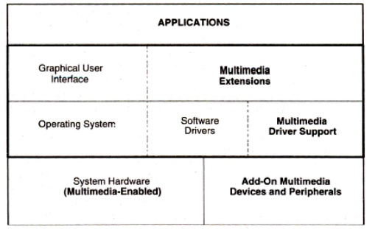
While focusing on multimedia system architecture, the most important point under consideration is on multimedia applications.
• Applications can be training app, conferencing app, messaging app, education app.
After that multimedia application interface with windows or with presentation manager.
• API’s support wide range of applications for publishing and interacting with applications.
• Multimedia applications such as educational, online training electronic messaging, and video conferencing kind of applications we are using at very first level of architecture.
• Multimedia architecture is of three types:
•Multimedia workstation architecture
• IMA architectural framework
• Network Architecture for multimedia systems

Distributed Multimedia Application:
If the multimedia systems are supported by multiuser system, then we call those multimedia systems as distributed multimedia systems.
A multi user system designed to support multimedia applications for a large number of users consists of a number of system components. A typical multimedia application environment consists of the following components:
1. Application software.
2. Container object store.
3. Image and still video store.
4. Audio and video component store.
5. Object directory service agent.
6. component service agent.
7. User interface and service agent.
8. Networks (LAN and WAN).

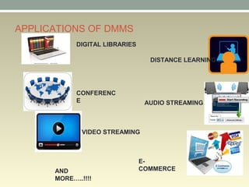

Applications of Multimedia Database
As discussed, there are many applications of a multimedia database. Some of the main applications include:
- Documents and record management: Multimedia databases are used in industries that require a large set of documentation and records, like the insurance claim industry, etc.
- Education: As multimedia data provides an interactive way to represent data, a multimedia database can act as an effective knowledge dissemination tool. These applications include the use of multimedia datasets in digital libraries and computer-aided learning software.
- Marketing and Entertainment: A Multimedia database can act as a data provider for entertainment applications like video-on-demand apps, news-on-demand apps, etc. It can provide multimedia data for advertisements and digital marketing processes.
- Real-time Monitoring: Combining various software tools with a multimedia database can allow us to monitor and manage multimedia data in real time. For example, a geographic information system (GIS) makes use of multimedia databases to analyze and visualize geographical multimedia data in real time.
- Marketing
- Advertisement
- Retailing
- Entertainment
- Travel

MMDBS:
Multimedia database is the collection of interrelated multimedia data that includes text, graphics (sketches, drawings), images, animations, video, audio etc and have vast amounts of multisource multimedia data. The framework that manages different types of multimedia data which can be stored, delivered and utilized in different ways is known as multimedia database management system. There are three classes of the multimedia database which includes static media, dynamic media and dimensional media.
Types of Multimedia Database
Based on the type of multimedia data it stores, the multimedia database is categorized into three types:
- Static media: These multimedia datasets are specifically used for static media objects, i.e., those objects which are independent of time constraints, such as images and graphic objects.
- Dynamic media: These datasets are used to store dynamic forms of media content, i.e., those multimedia data elements which are time-dependent, like audio data, video data, and animations.
- Dimensional media: Dimensional multimedia datasets are typically used in Computer-Aided Drafting programs. These operate on 3D multimedia data and include various formats used by image and video editing applications.

The contents of a multimedia database management system can be:
- Media data: It is the actual data which represents an object.
- Media format data: The information such as resolution, sampling rate, encoding system, etc. about the format of the media data under consideration after is undergoes acquisition, processing, and encoding is the media format data.
- Media keyword data: Media keyword data are the keyword description related to the generation of data. This data is also known as content descriptive data. Examples of content descriptive data are place, time, date of recording.
- Media feature data: Media feature data contains data which is content dependent such as kind of texture, distribution of, and the different shapes present in the data.

Advantages of multimedia database
•If we want to handle the huge database effectively, the multimedia database is our best choice.
•It will accelerate the development of multimedia apps in various fields, such as libraries system and teaching.
•Multimedia databases make the lecture more interesting and vivid.
•It supports multiple users operation.
•It is flexible. These media can be easily switched to different types to fit the different situations and audiences.

