UNIT-II

ER model
- ER model stands for an Entity-Relationship model. It is a high-level data model. This model is used to define the data elements and relationship for a specified system.
- It develops a conceptual design for the database. It also develops a very simple and easy to design view of data.
- In ER modeling, the database structure is portrayed as a diagram called an entity-relationship diagram.
For example, Suppose we design a school database. In this database, the student will be an entity with attributes like address, name, id, age, etc. The address can be another entity with attributes like city, street name, pin code, etc and there will be a relationship between them.
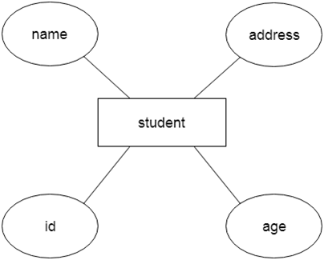

Component of ER Diagram
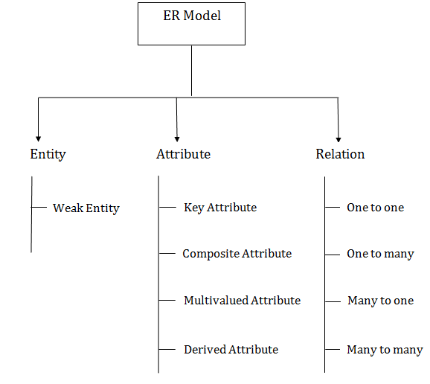

1. Entity:
An entity may be any object, class, person or place. In the ER diagram, an entity can be represented as rectangles.
Consider an organization as an example- manager, product, employee, department etc. can be taken as an entity.
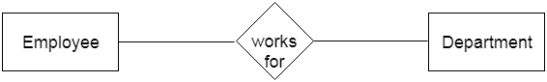
a. Weak Entity
An entity that depends on another entity called a weak entity. The weak entity doesn't contain any key attribute of its own. The weak entity is represented by a double rectangle.

2. Attribute
The attribute is used to describe the property of an entity. Eclipse is used to represent an attribute.
For example, id, age, contact number, name, etc. can be attributes of a student.
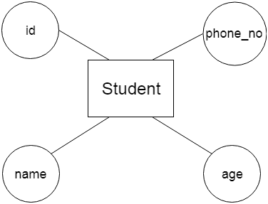
a. Key Attribute
The key attribute is used to represent the main characteristics of an entity. It represents a primary key. The key attribute is represented by an ellipse with the text underlined.
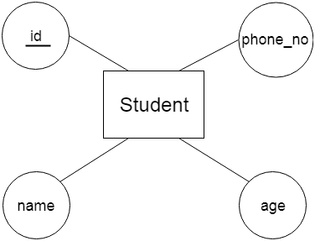
b. Composite Attribute
An attribute that composed of many other attributes is known as a composite attribute. The composite attribute is represented by an ellipse, and those ellipses are connected with an ellipse.
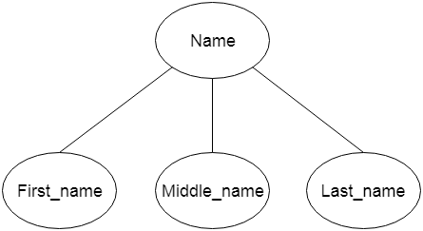
c. Multivalued Attribute
An attribute can have more than one value. These attributes are known as a multivalued attribute. The double oval is used to represent multivalued attribute.
For example, a student can have more than one phone number.
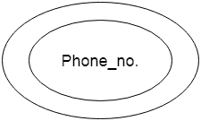
d. Derived Attribute
An attribute that can be derived from other attribute is known as a derived attribute. It can be represented by a dashed ellipse.
For example, A person's age changes over time and can be derived from another attribute like Date of birth.
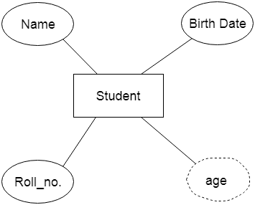

3. Relationship
A relationship is used to describe the relation between entities. Diamond or rhombus is used to represent the relationship.
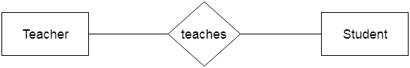
Types of relationship are as follows:
a. One-to-One Relationship
When only one instance of an entity is associated with the relationship, then it is known as one to one relationship.
For example, A female can marry to one male, and a male can marry to one female.
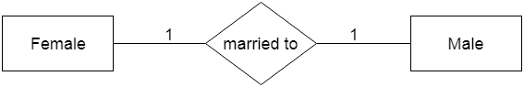
b. One-to-many relationship
When only one instance of the entity on the left, and more than one instance of an entity on the right associates with the relationship then this is known as a one-to-many relationship.
For example, Scientist can invent many inventions, but the invention is done by the only specific scientist.
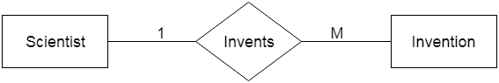
c. Many-to-one relationship
When more than one instance of the entity on the left, and only one instance of an entity on the right associates with the relationship then it is known as a many-to-one relationship.
For example, Student enrolls for only one course, but a course can have many students.
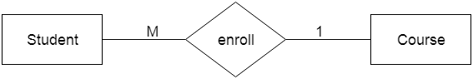
d. Many-to-many relationship
When more than one instance of the entity on the left, and more than one instance of an entity on the right associates with the relationship then it is known as a many-to-many relationship.
For example, Employee can assign by many projects and project can have many employees.
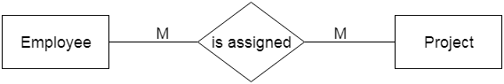

Notation of ER diagram
Database can be represented using the notations. In ER diagram, many notations are used to express the cardinality. These notations are as follows:
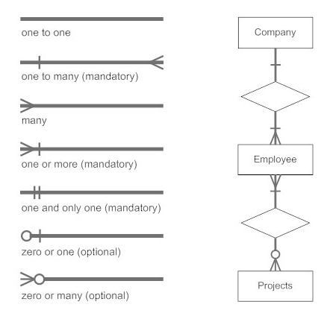
Fig: Notations of ER diagram

Functional Dependency
The functional dependency is a relationship that exists between two attributes. It typically exists between the primary key and non-key attribute within a table.
- X → Y
The left side of FD is known as a determinant, the right side of the production is known as a dependent.
For example:
Assume we have an employee table with attributes: Emp_Id, Emp_Name, Emp_Address.
Here Emp_Id attribute can uniquely identify the Emp_Name attribute of employee table because if we know the Emp_Id, we can tell that employee name associated with it.
Functional dependency can be written as:
- Emp_Id → Emp_Name
We can say that Emp_Name is functionally dependent on Emp_Id.

Types of Functional dependency
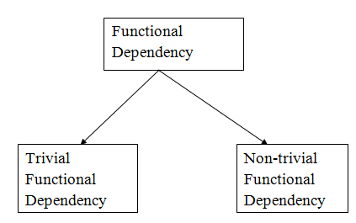

1. Trivial functional dependency
- A → B has trivial functional dependency if B is a subset of A.
- The following dependencies are also trivial like: A → A, B → B
Example:
- Consider a table with two columns Employee_Id and Employee_Name.
- {Employee_id, Employee_Name} → Employee_Id is a trivial functional dependency as
- Employee_Id is a subset of {Employee_Id, Employee_Name}.
- Also, Employee_Id → Employee_Id and Employee_Name → Employee_Name are trivial dependencies too.

2. Non-trivial functional dependency
- A → B has a non-trivial functional dependency if B is not a subset of A.
- When A intersection B is NULL, then A → B is called as complete non-trivial.
Example:
- ID → Name,
- Name → DOB
- Decomposition in DBMS removes redundancy, anomalies and inconsistencies from a database by dividing the table into multiple tables.
- The following are the types −

Lossless Decomposition
- Decomposition is lossless if it is feasible to reconstruct relation R from decomposed tables using Joins. This is the preferred choice. The information will not lose from the relation when decomposed. The join would result in the same original relation.
- Let us see an example −
- <EmpInfo>
Emp_ID | Emp_Name | Emp_Age | Emp_Location | Dept_ID | Dept_Name
E001 | Jacob | 29 | Alabama | Dpt1 | Operations
E002 | Henry | 32 | Alabama | Dpt2 | HR
E003 | Tom | 22 | Texas | Dpt3 | Finance
- Decompose the above table into two tables:
- <EmpDetails>
Emp_ID | Emp_Name | Emp_Age | Emp_Location
E001 | Jacob | 29 | Alabama
E002 | Henry | 32 | Alabama
E003 | Tom | 22 | Texas
- <DeptDetails>
Dept_ID | Emp_ID | Dept_Name
Dpt1 | E001 | Operations
Dpt2 | E002 | HR
Dpt3 | E003 | Finance
- Now, Natural Join is applied on the above two tables −
- The result will be −
Emp_ID | Emp_Name | Emp_Age | Emp_Location | Dept_ID | Dept_Name
E001 | Jacob | 29 | Alabama | Dpt1 | Operations
E002 | Henry | 32 | Alabama | Dpt2 | HR
E003 | Tom | 22 | Texas | Dpt3 | Finance
- Therefore, the above relation had lossless decomposition i.e. no loss of information.

First Normal Form (1NF)
- A relation will be 1NF if it contains an atomic value.
- It states that an attribute of a table cannot hold multiple values. It must hold only single-valued attribute.
- First normal form disallows the multi-valued attribute, composite attribute, and their combinations.
Example: Relation EMPLOYEE is not in 1NF because of multi-valued attribute EMP_PHONE.
EMPLOYEE table:
EMP_ID | EMP_NAME | EMP_PHONE | EMP_STATE
14 | John | 7272826385,  9064738238 | UP
20 | Harry | 8574783832 | Bihar
12 | Sam | 7390372389,  8589830302 | Punjab
The decomposition of the EMPLOYEE table into 1NF has been shown below:
EMP_ID | EMP_NAME | EMP_PHONE | EMP_STATE
14 | John | 7272826385 | UP
14 | John | 9064738238 | UP
20 | Harry | 8574783832 | Bihar
12 | Sam | 7390372389 | Punjab
12 | Sam | 8589830302 | Punjab

Second Normal Form (2NF)
- In the 2NF, relational must be in 1NF.
- In the second normal form, all non-key attributes are fully functional dependent on the primary key
Example: Let's assume, a school can store the data of teachers and the subjects they teach. In a school, a teacher can teach more than one subject.
TEACHER table
TEACHER_ID | SUBJECT | TEACHER_AGE
25 | Chemistry | 30
25 | Biology | 30
47 | English | 35
83 | Math | 38
83 | Computer | 38
In the given table, non-prime attribute TEACHER_AGE is dependent on TEACHER_ID which is a proper subset of a candidate key. That's why it violates the rule for 2NF.
To convert the given table into 2NF, we decompose it into two tables:
TEACHER_DETAIL table:
TEACHER_ID | TEACHER_AGE
25 | 30
47 | 35
83 | 38
TEACHER_SUBJECT table:
TEACHER_ID | SUBJECT
25 | Chemistry
25 | Biology
47 | English
83 | Math
83 | Computer

Third Normal Form (3NF)
- A relation will be in 3NF if it is in 2NF and not contain any transitive partial dependency.
- 3NF is used to reduce the data duplication. It is also used to achieve the data integrity.
- If there is no transitive dependency for non-prime attributes, then the relation must be in third normal form.
A relation is in third normal form if it holds atleast one of the following conditions for every non-trivial function dependency X → Y.
- X is a super key.
- Y is a prime attribute, i.e., each element of Y is part of some candidate key.
Example:
EMPLOYEE_DETAIL table:
EMP_ID | EMP_NAME | EMP_ZIP | EMP_STATE | EMP_CITY
222 | Harry | 201010 | UP | Noida
333 | Stephan | 02228 | US | Boston
444 | Lan | 60007 | US | Chicago
555 | Katharine | 06389 | UK | Norwich
666 | John | 462007 | MP | Bhopal
Super key in the table above:
  - {EMP_ID}, {EMP_ID, EMP_NAME}, {EMP_ID, EMP_NAME, EMP_ZIP}....so on
Candidate key: {EMP_ID}
Non-prime attributes: In the given table, all attributes except EMP_ID are non-prime.
Here, EMP_STATE & EMP_CITY dependent on EMP_ZIP and EMP_ZIP dependent on EMP_ID. The non-prime attributes (EMP_STATE, EMP_CITY) transitively dependent on super key(EMP_ID). It violates the rule of third normal form.
That's why we need to move the EMP_CITY and EMP_STATE to the new <EMPLOYEE_ZIP> table, with EMP_ZIP as a Primary key.
EMPLOYEE table:
EMP_ID | EMP_NAME | EMP_ZIP
222 | Harry | 201010
333 | Stephan | 02228
444 | Lan | 60007
555 | Katharine | 06389
666 | John | 462007
EMPLOYEE_ZIP table:
EMP_ZIP | EMP_STATE | EMP_CITY
201010 | UP | Noida
02228 | US | Boston
60007 | US | Chicago
06389 | UK | Norwich
462007 | MP | Bhopal

Boyce Codd normal form (BCNF)
- BCNF is the advance version of 3NF. It is stricter than 3NF.
- A table is in BCNF if every functional dependency X → Y, X is the super key of the table.
- For BCNF, the table should be in 3NF, and for every FD, LHS is super key.
Example: Let's assume there is a company where employees work in more than one department.
EMPLOYEE table:
EMP_ID | EMP_COUNTRY | EMP_DEPT | DEPT_TYPE | EMP_DEPT_NO
264 | India | Designing | D394 | 283
264 | India | Testing | D394 | 300
364 | UK | Stores | D283 | 232
364 | UK | Developing | D283 | 549
In the above table Functional dependencies are as follows:
- EMP_ID → EMP_COUNTRY
- EMP_DEPT → {DEPT_TYPE, EMP_DEPT_NO}
Candidate key: {EMP-ID, EMP-DEPT}
The table is not in BCNF because neither EMP_DEPT nor EMP_ID alone are keys.
To convert the given table into BCNF, we decompose it into three tables:
EMP_COUNTRY table:
EMP_ID | EMP_COUNTRY
264 | India
264 | India
EMP_DEPT table:
EMP_DEPT | DEPT_TYPE | EMP_DEPT_NO
Designing | D394 | 283
Testing | D394 | 300
Stores | D283 | 232
Developing | D283 | 549
EMP_DEPT_MAPPING table:
EMP_ID | EMP_DEPT
D394 | 283
D394 | 300
D283 | 232
D283 | 549
Functional dependencies:
- EMP_ID → EMP_COUNTRY
- EMP_DEPT → {DEPT_TYPE, EMP_DEPT_NO}
Candidate keys:
For the first table: EMP_ID
For the second table: EMP_DEPT
For the third table: {EMP_ID, EMP_DEPT}
Now, this is in BCNF because left side part of both the functional dependencies is a key.

Dependency Preserving
- It is an important constraint of the database.
- In the dependency preservation, at least one decomposed table must satisfy every dependency.
- If a relation R is decomposed into relation R1 and R2, then the dependencies of R either must be a part of R1 or R2 or must be derivable from the combination of functional dependencies of R1 and R2.
- For example, suppose there is a relation R (A, B, C, D) with functional dependency set (A->BC). The relational R is decomposed into R1(ABC) and R2(AD) which is dependency preserving because FD A->BC is a part of relation R1(ABC).

