MAGNETIC EFFECTS OF ELECTRIC CURRENT

Magnetic field: The area around a magnet where a magnetic force is experienced is called the magnetic field. It is a quantity that has both direction and magnitude, (i.e., Vector quantity). It is denoted by B
SI unit of magnetic field is Tesla (T).

Magnetic field lines:
The imaginary lines of magnetic field around a magnet are called field line or field line of magnet. When iron fillings are allowed to settle around a bar magnet, they get arranged in a pattern which represents the magnetic field lines. Field line of a magnet can also be detected using a compass.
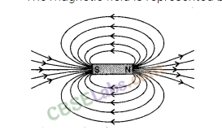
Direction of field line: Outside the magnet, the direction of magnetic field line is taken from North pole to South Pole. Inside the magnet, the direction of magnetic field line is taken from South pole to North pole.
Strength of magnetic field: The closeness of field lines shows the relative strength of magnetic field, i.e. closer lines show stronger magnetic field and vice – versa. Crowded field lines near the poles of magnet show more strength.
Properties of magnetic field lines
(i) They do not intersect each other. If they did so, at the point of intersection they will point in two directions which is not possible
(ii) It is taken by convention that magnetic field lines emerge from North pole and merge at the South pole.That is outside the magnet it is directed from north pole to south pole. Inside the magnet, their direction is from South pole to North pole. Therefore magnetic field lines are closed curves.
(iii) The direction of magnetic field at a point is given by the tangent drawn to the field line at that point.
(iv) Uniform magnetic field is represented by parallel lines.

Magnetic field due to a straight current carrying conductor
Han Christian Oersted conducted an experiment in which he could see the deflection in a compass needle placed near a current carrying conductor.
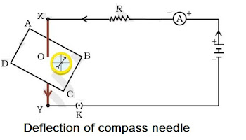
This shows that there exists a magnetic field around a straight current carrying conductor and it is in the form of concentric circular field lines as shown below.
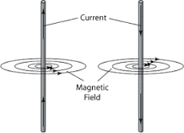
The direction of the magnetic field is given by right hand thumb rule
Magnetic field lines are closer near the conductor
Magnetic field is directly proportional to the current flowing through it.
B α I
Magnetic field is inversely proportional to the distance from the conductor.
B α 1/d

RIGHT HAND THUMB RULE:
You can find it by pointing your right thumb in the direction of the current in the wire and curling your fingers. Your fingers will be curled in the same direction as the magnetic field around the wire.
That is, if the thumb is pointing upwards, the fingers will be curled in the anti clock wise (a.c.w) direction and if the thumb is pointing downwards, the fingers will be curled in the clock wise(c.w) direction
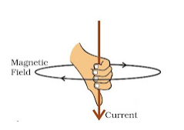
Magnetic field due to a straight current carrying circular loop
It can be represented by concentric circle at every point.
The circle gets larger as we move towards the centre.
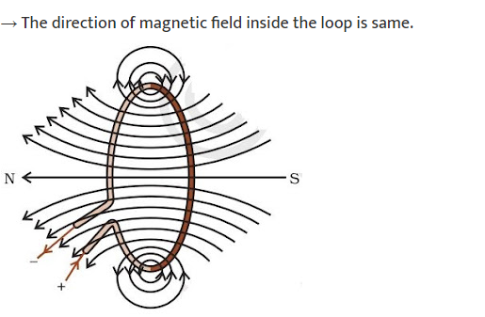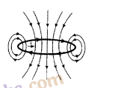

Factors affecting magnetic field of a circular current carrying conductor-
- Magnetic field is directly proportional to the current passing through the conductor.
- Magnetic field is inversely proportional to the distance from the conductor.
- The strength of the magnetic field is inversely proportional to the radius of the coil. If the radius increases, the magnetic strength at the centre decreases
- Magnetic field is directly proportional to number of turns in coil.
The direction of magnetic field is given by RH thumb rule. Let us assume that the current is moving in anti-clockwise direction in the loop. In that case, the magnetic field would be in clockwise direction, at the top of the loop. Moreover, it would be in an anti-clockwise direction at the bottom of the loop.
Solenoid
Solenoid is the coil with many circular turns of insulated copper wire wrapped closely in the shape of a cylinder. A current carrying solenoid produces similar pattern of magnetic field as a bar magnet. One end of solenoid behaves as the north pole and another end behaves as the south pole.
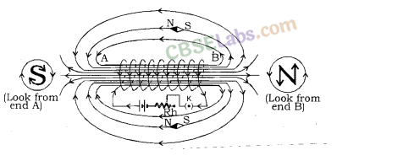
- Magnetic field lines are parallel inside the solenoid, similar to a bar magnet, which shows that magnetic field is same at all points inside the solenoid.
- Magnetic field produced by a solenoid is similar to a bar magnet.
- The strength of magnetic field is proportional to the number of turns and magnitude of current.
- By producing a strong magnetic field inside the solenoid, magnetic materials can be magnetized. Magnet formed by producing magnetic field inside a solenoid is called electromagnet.
Force on a current carrying conductor in a magnetic field: When a current carrying conductor is placed in an external magnetic field, it experiences a force except when it is placed parallel to the magnetic field.
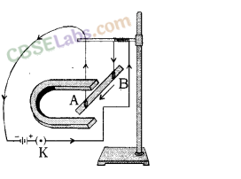
The direction of force over the conductor gets reversed with the change in direction of flow of electric current. It is observed that the magnitude of force is highest when the direction of current is at right angles to the magnetic field.The direction of force is given by Fleming’s left hand rule.
The Fleming’s Left Hand Rule states that if the left hand is stretched in a way that the index finger, the middle finger and the thumb are in mutually perpendicular directions, then the index finger and middle finger of a stretched left hand show the direction of magnetic field and direction of electric current respectively and the thumb shows the direction of motion or force acting on the conductor. The directions of electric current, magnetic field and force are similar to three mutually perpendicular axes, i.e. x, y, and z-axes.
Many devices, such as electric motor, electric generator, loudspeaker, etc. work on Fleming’s Left Hand Rule
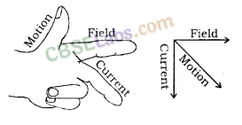
A.C and D.C Current
A.C – Alternate Current: Current in which direction is changed periodically is called Alternate Current. In India, most of the power stations generate alternate current. The direction of current changes after every 1/100 second in India, i.e. the frequency of A.C in India is 50 Hz. A.C is transmitted upto a long distance without much loss of energy is advantage of A.C over D.C.
D.C – Direct Current: Current that flows in one direction only is called Direct current. Electrochemical cells produce direct current.
Advantages of A.C over D.C
- Cost of generator of A.C is much less than that of D.C.
- A.C can be easily converted to D.C.
- A.C can be controlled by the use of choke which involves less loss of power whereas, D.C can be controlled using resistances which involves high energy loss.
- AC can be transmitted over long distances without much loss of energy.
- AC machines are stout and durable and do not need much maintenance.
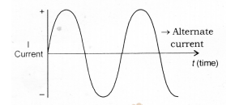
Disadvantages of AC
- AC cannot be used for the electrolysis process or showing electromagnetism as it reverses its polarity.
- AC is more dangerous than DC.
Domestic Electric Circuits: We receive electric supply through mains supported through the poles or cables. In our houses, we receive AC electric power of 220 V with a frequency of 50 Hz.
The 3 wires are as follows
- Live wire – (Red insulated, Positive)
- Neutral wire – (Black insulated, Negative)
- Earth wire – (Green insulated) for safety measure to ensure that any leakage of current to a metallic body does not give any serious shock to a user.
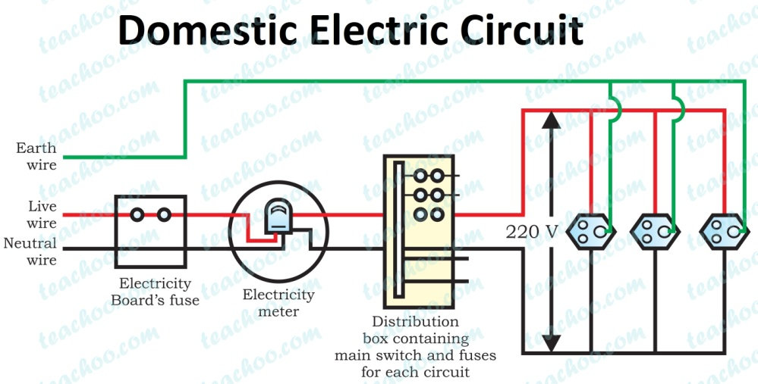
Short Circuit: Short-circuiting is caused by the touching of live wires and neutral wire and sudden a large current flows.
It happens due to
- damage pf insulation in power lines.
- a fault in an electrical appliance.
Overloading of an Electric Circuit: The overheating of electrical wire in any circuit due to the flow of a large current through it is called overloading of the electrical circuit.
A sudden large amount of current flows through the wire, which causes overheating of wire and may cause fire also.
Electric Fuse: It is a protective device used for protecting the circuit from short-circuiting and overloading. It is a piece of thin wire of material having a low melting point and high resistance.
- Fuse is always connected to live wire.
- Fuse is always connected in series to the electric circuit.
- Fuse is always connected to the beginning of an electric circuit.
- Fuse works on the heating effect.

