TERM – II
REVISION-1
Name :
Subject: AI
Grade : II
I. Tick the correct answers.
1. Which 3d tool is used to draw a sphere?
a.Circle b.Sphere c.Star
2. Which of the following is not an alphabet key?
a.A b.k c.Enter key
3. It erases anything typed to the right of the cursor.
a.Delete key b.Backspace key c.Enter key
4. Paint 3D was released on.
a.5th April 2017 b.5th August 2017 c.5th July 2017
5. Which of the following is a component of Paint 3D Window?
a.Oil brushes b.Sphere tool c.Both a and b
6. The symbol keys are present on the upper part of the
a.Capslock b.Alphabet keys c.Number keys
7. Which of these options is not used to capitalise letters?
a.Shift b.Arrow Keys c.Capslock
8. Which tool is used to erase a drawing?
a.Paint b.Eraser c.Text

II. Match the following

Components Of Paint 3d Window

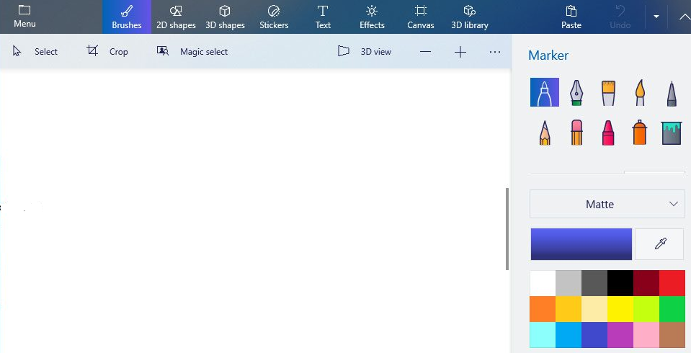
Marker PAINT 3D WINDOW

Eraser
Fill
Spray
Color Palette

