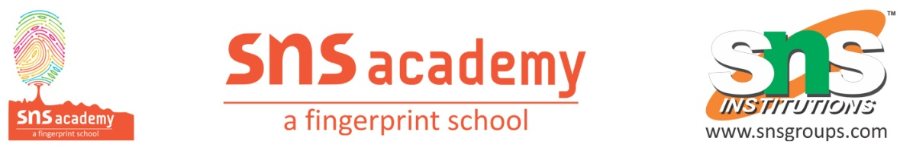
Computer science
Worksheet -3
Date:03.09.2022 Class:XI
Marks:
1.Differentiate between code space and code point?
2.What are UTF-8 and UTF-32 encoding schemes.Which one is more popular encoding schemes?
3.What is the difference between fixed length and variable length encoding schemes?
4.Given that A’s code point in ASCII is 65,and a code point is 97.What is the binary representation of A in ASCII?(and what’s its hexadecimal representation).What is the binary representation of a in ASCII?
5.Convert the following binary numbers to decimal ,octal and hexadecimal numbers?
(a) 100101.101 (b)10101100.01011 (c)10101100.010111 (d)1010

