PUZZLE-3

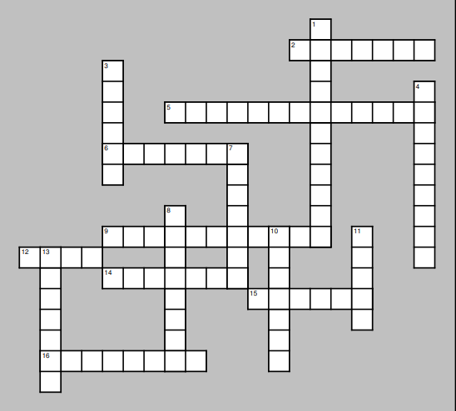

DOWN

8. shown or made known
10. different sides or ways of looking at
something
11. to make a logical guess that
something is true based on the
evidence, although the evidence is
not clear enough to be absolutely
certain
13. to look at something carefully to find
problems or specific information

