PUZZLE- 2

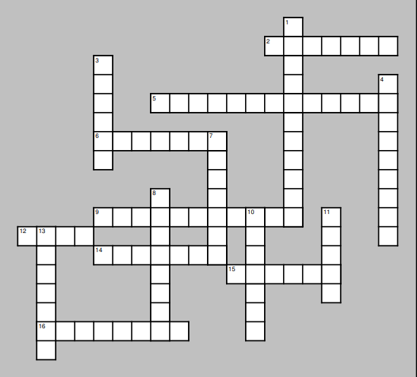

DOWN
1.Curious; wants to understand things
3. related to the mind
4. a person whose job is to find or recognize the hidden information needed to solve a crime
7. to look closely at something

