PUZZLE - 1

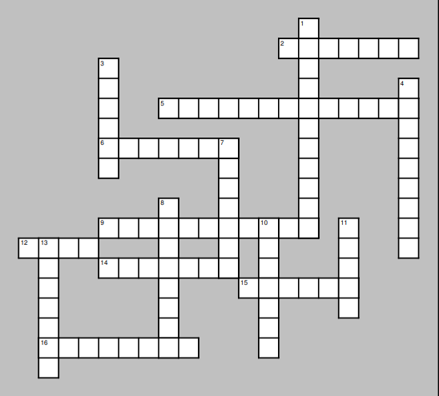

ACROSS
12. a connection; one part of a chain
14. to notice or watch
15. to figure out something unknown by considering all its known aspects and reasoning it through
16. to consider the evidence and then decide what is true or correct (OR to end something)

