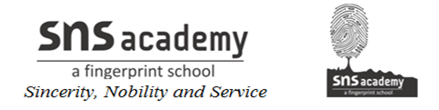

CLASS: 12 ACTIVITY - 1

You are the Director of Health Services , Mizoram. You have to educate the public about the necessity of oral polio vaccine for small children. Design a simple and catchy poster to be put up at prominent locations in the whole state.

