AGRICULTURE
TECHNOLOGY IN AGRICULTURE

Agricultural technology or agro technology is the use of technology in agriculture, horticulture, and aquaculture with the aim of improving yield, efficiency, and profitability. Agricultural technology can be products, services or applications derived from agriculture that improve various input/output processes.
Advances in agricultural science, agronomy, and agricultural engineering have led to applied developments in agricultural technology. Major turning point for agricultural technology is the Industrial Revolution, which introduced agricultural machinery to mechanize the labour of agriculture, greatly increasing farm worker productivity. In modern mechanized agriculture powered machinery has replaced many farm jobs formerly carried out by manual labour or by working animals such as oxen, horses and mules.
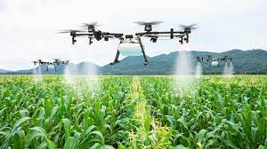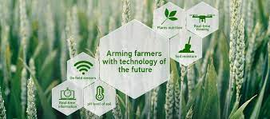

The 20th century saw major advances in agricultural technologies, including the development of synthetic fertilizers and pesticides, and new agricultural machinery.
In the first decades of the 21st century, Information Age technologies have been increasingly applied to agriculture. Agricultural robots, agricultural drones and driverless tractors have found regular use on farms, while digital agriculture and precision agriculture make use of extensive data collection and computation to improve farm efficiency. Precision agriculture includes such areas as precision beekeeping, precision livestock farming, and precision viticulture.
Including technology to farming helps farmers to increase the efficiency and to improve the quality. Hence farmers will have a annual income which would help them to set a standard life.
PREPARED BY: REMYASREE K
LINKEDIN LINK:
YOUTUBE LINK:

