SOCIAL STUDIES
GRADE: V DATE: 18 .1.21
NAME:
WORKSHEET-18(GOVERNING OURSELVES)
I.WRITE TRUE OR FALSE AND REWRITE THE CORRECT SENTENCES.
1. The constitution of India provides for a government at the centre only. _________________ .
_______________________________________________________________ .
2. The union government makes laws for the whole country. . _________________
______________________________________________________________ .
3. The Rajya Sabha can have a maximum of 552 members. _________________
_______________________________________________________________ .
4. The Prime Minister of India is the head of the country. _________________
______________________________________________________________ .
5. The Chief Minister appoints the judges of the Supreme Court. _________________
_____________________________________________________________ .
II.Unscramble the letters to get the correct words. Write one line each on the words you get.
1. LIAPMARNTE: _________________
________________________________________________________________
2. WRELO OSEHU: _________________
________________________________________________________________
3. ICEV RSESEIDNTE: _________________
________________________________________________________________
4. RIPME NISMITER: _________________
________________________________________________________________
5. ORNGOERV: _________________
________________________________________________________________
6. CIEHF UJTCEIS: _________________
________________________________________________________________
7. IGHH URTCO: _________________
________________________________________________________________
III.ANSWER THRE FOLLOWING
1. What does the Parliament consist of?
________________________________________________________________________________________________________________________________.
2. Who elects the speaker? What does She/He do?
________________________________________________________________________________________________________________________________.
3. How are the members of the Rajya Sabha elected?
________________________________________________________________________________________________________________________________.

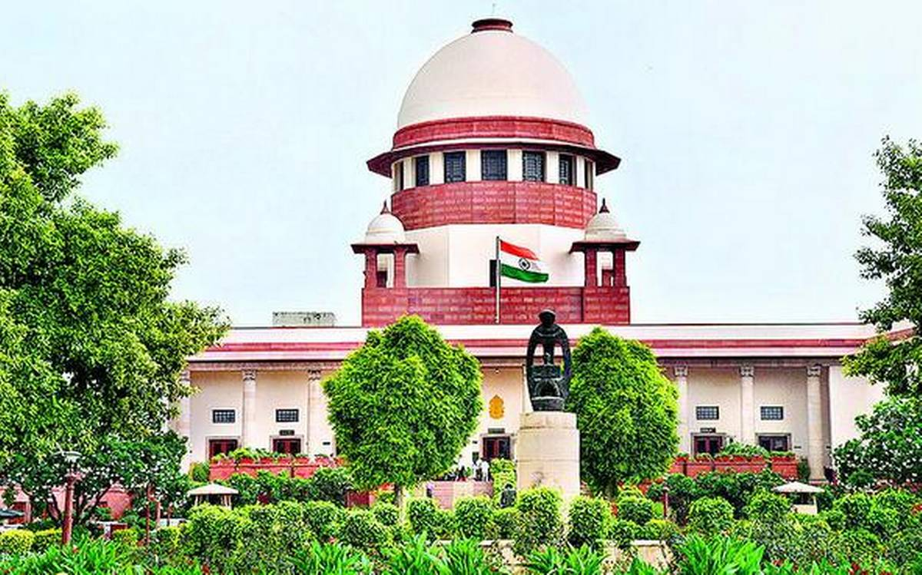
IV.LOOK AT THE PICTURE.ANSWER THE QUESTIONS

1. Name the building.
________________________________________________________________.
2. Where is it located?
________________________________________________________________.
3. What is the importance of the building?
________________________________________________________________.

