Title - Development (Chap-1)

2016

Very Short Answer Type Questions [1 Mark]

Ques 1.
Why is Per Capita Income calculated in the US dollars?
Ans: The Per Capita Income is calculated in the US dollars because US dollar is considered as the medium of international exchange. It is accepted as method of payment across the world.

Short Answer Type Questions [3 Marks]

Ques 2. “People have conflicting development goals”. Support the statement with suitable example.
Ans: It is true to say that people have conflicting developmental goals. What may be the development for one may not be for the other. Different people have different interests, life situations and state of mind. They visualize things, actions, etc. according to their level of understanding.
For example, the construction of a flyover to reduce the congestion and traffic jams may be a development goal especially for the daily commuters. But for the construction of the flyover, surrounding houses, shops, etc. need to be demolished which may not be like by the occupants of these shops and houses. This may not be a development goal for them.

Ques 3. Describe any three possible development goals of landless rural labourers. Ans: The following can be the developmental goals of landless rural labourers.

- More days of work with better wages.
- Social and economic equality.
- Low price food grains.
- Better education facilities for their children.

Ques 4. “Money cannot buy all the goods and services that one needs to live well” Do you agree with this statement? Justify your answer with any three suitable arguments.
Ans: Yes, we agree with the statement that money cannot buy all the goods and services that one needs to live well because of the following reasons.

- Money can buy things that can be one factor on which our life depends like food. But the quality of non-material things like freedom, security and respect cannot be bought with money.
- We cannot buy pollution free environment, unadulterated medicines and peace with money.
- Schools, colleges, parks, hospitals, etc. are the facilities which cannot be run individually. There has to be a collective effort of team work between the government or society in providing these to the general public.

2015
Very Short Answer Type Questions [1 Mark]

Ques 5. Give any two common developmental goals of the people.
Ans: Social equality, freedom, peace, pollution-free environment, improved health and literacy levels, awareness and control on population are common development goals of the people.

Ques 6. Suggest any one way to solve under-employment situation in rural areas.
Ans: The problem of under employment in the rural areas can be solved by setting up industries, schools, tourism, regional craft industry, information technology, etc

Ques 7. Mention any one limitation of per capita income as an indicator of development. Ans: One limitation of per capita income is that it is impossible to come out to a well-defined conclusion about the real income of the people or nation

Ques 8. Through which act is Right to Work implemented?
Ans: Right to Work is implemented through National Rural Employment Guarantee Act (NREGA) 2005.

Ques 9. What is the rank of India as per the HDI report of 2004? Ans: India ranked 127 as per the HDI report of 2004.

Ques 10. Define average income.
Ans: Average income measures the average income earned per person in a given area in a specified year. It is calculated by dividing the area’s total income by its total population.

Ques 11. Differentiate between Human Development Report and World Development Ans: The following are the differences between Human Development Report and World Development Report.

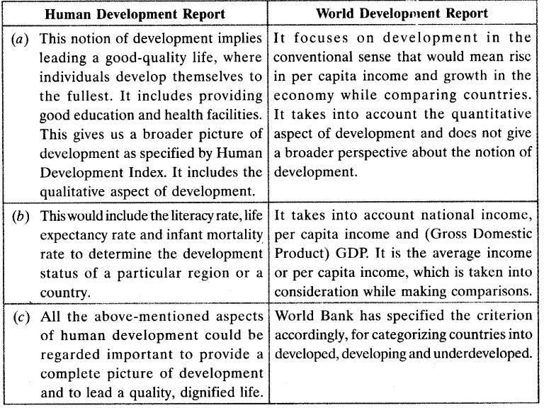

Ques 12. Why does Kerala have a better Human Development Index ranking in comparison to Punjab? Explain with three reasons.
Ans: Kerala has a better Human Development Index ranking in comparison to Punjab even though Punjab has a higher per capita income in comparison to Kerala because of the following reasons.

- Education: Kerala has a higher level of literacy rate than Punjab. In fact, the literacy rate of Kerala is the highest in India. In Kerala, the literacy rate is ninety-one per cent which is almost as high as that of China. This is mainly because education has been made available to everyone in Kerala whether they are upper caste or the lower caste. There is no bias in the field of education, which is one of the major reasons why Kerala has a better HDI than Punjab.
- Health care: The health care facilities in Kerala are far better than those in Punjab. Kerala has over 2700 government medical hospitals, with 330 beds per 1,00,000 population which is the highest in India, making it achieve a higher ranking in the HDI.
- Politics: The political parties in Kerala have taken steps for genuine welfare of the people and have invested intelligently and methodologically in the field of health and education. The government of Kerala has even worked for the land reforms in the State to support the people.

Ques 13. What is the main norm used by the World Bank in classifying different countries as rich and poor countries? What are the restrictions of such norms?
Ans: Average income or per capita income is the main domain used by the World Bank in classifying different coutries as rich and poor countries. According to the World Bank, income is one of the most important attributes. Countries with average income of USD 12616 per annum

and above are called rich countries. Countries with average income of USD 1530 or less are called middle-income countries and countries with average income of USD 1035 or less are called poor countries.
This is based on the conception that the higher the total income of the country, the developed it is.
However, there are certain restrictions to this norm because income, although an important measure for calculating growth and development, is not the only attribute. Over the past few decades, health and education have made an important mark in the development of a country. So, even if the country has high per capita income and literacy rate but does not have good medical facilities, it cannot be considered developed.

Ques 14. Besides income, what are the six other things people may look for growth and development?
Ans: The following are the six things that people may look for growth and development, besides income.

- freedom
- security
- respect
- quality of life
- health
- education

Long Answer Type Questions [5 Marks]

Ques 15. “Though the level of income is important, it is an inadequate measure of the level of development.” Justify the statement.
Ans: It is true that income is an important way to measure the level of development but it is also true that it is not the only way to measure the level of development. It is an inadequate method of measuring development since it is only the materialistic measure of development based on money.
Over the past few decades, health, education, sanitary and other non-materialistic indicators have become an important criteria in measuring the level of development.
The Human Development Index, for example, is a better measure of development since it takes into consideration health and education indicators as well.
For example, even though the income of Punjab is more than that of Kerala, Kerala has a higher HDI because it has better health and educational facilities. The literacy rate of Kerala is higher than that of Punjab.

Ques 16. What is Human Development Index? Which organization measures the HDI? Explain the three major indicators of the HDI.
Ans: Human Development Index is a tool developed by the United Nations to measure and rank countries based on the level of social and economic development. The HDI makes it possible to track changes in development levels from time to time and to compare development levels in different countries. The concept of HDI goes beyond income and growth to cover overall development with the object of improving the conditions of people from all angles.

The organization that measures the HDI is the United Nations. Three major indicators of the HDI are as follows.

- Health: Without proper health facilities, no matter how much a country earns, it will not be able to provide basic facilities to its people.
- Education: Over the past few decades, education has become an important factor in leading a quality life. So, if the country has high income but the literacy rate is low, it cannot be considered developed.
- Security: More than income, people want to have a secured life. A country should be able to provides its citizens a sense of security.

2014
Very Short Answer Type Questions [1 Mark]

Ques 17. Suppose there are four families in a country with per capita income of $15000. The income of three families is $10000, $20000 and $12000. What is the income of the fourth family?
Ans: The income of the fourth family is $18,000.The income of the fourth family is $18,000.

Ques 18. Study the data given below and answer the Ques that follow. Some comparative data on Punjab, Kerala and Bihar:
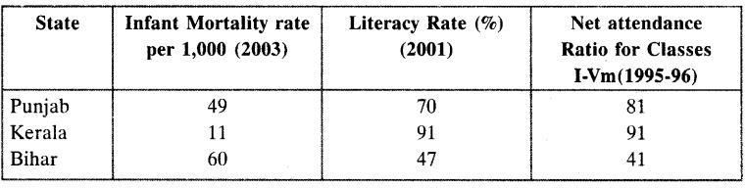

Which state appears the most developed? Ans: Kerala appears the most developed.

Ques 19. What may be the development for one may be the destruction for the other.” Explain the statement with appropriate examples.
Ans: Yes, it is true that what may be called development for some may turn out to be destruction for the others.
For example, the Sardar Sarovar dam built over the Narmada river led to a major evacuation of the tribes near the Narmada river and as a result the tribes lost their land and homes. This development of Sardar sarovar dam turned out to be a destruction for the tribes.
Another example, On the border of Madhya Pradesh and Uttar Pradesh, in the Singrauli region, over 200,000 people have been displaced on different occasions. First by the Rihand dam, then by a series of thermal power plants of the National Thermal Power Corporation. Singrauli has illuminated the lives of many in the urban centres, but has seen its natives groping in endless darkness, grappling to overcome the trauma of displacement. So the development in Singrauli

led to destruction of its people.
Multinational companies take away the land of the farmers for the construction of industries. It may be beneficial for boosting production but at the same time it causes loss of cultivable land and livelihood of the farmers. Various movements have been launched against the acquisition of land from the farmers.

2013
Short Answer Type Questions [3 Marks]

Ques 20. State the three factors other than human income, that are important in life.
Ans: Human Development Index is a tool developed by the United Nations to measure and rank countries based on the level of social and economic development. The HDI makes it possible to track changes in development levels from time to time and to compare development levels in different countries. The concept of HDI goes beyond income and growth to cover overall development with the object of improving the conditions of people from all angles.
The organization that measures the HDI is the United Nations. Three major indicators of the HDI are as follows

- Health: Without proper health facilities, no matter how much a country earns, it will not be able to provide basic facilities to its people.
- Education: Over the past few decades, education has become an important factor in leading a quality life. So, if the country has high income but the literacy rate is low, it cannot be considered developed.
- Security: More than income, people want to have a secured life. A country should be able to provides its citizens a sense of security.

Ques 21. Explain the importance of sustainable development with reference to groundwater by giving example.
Ans: Sustainable development means a development in a manner that satisfies the demands of today without hampering or compromising the ability of the future generations to meet their needs by utilizing the resources.
In lay man’s language it means using the resources in a manner that you and the future generations can use them tomorrow as well.
It is important because of the reason that we may enjoy the gifts of nature, but cannot think of our generations to live without such benefits. It becomes our duty to use nature for the fulfillment of our needs and not our greed. Our development should not hamper the needs of the future generations.
In the case of groundwater, we have utilized it to the maximum. It is a natural resource which is replenished by nature. People living in the areas with surplus water reserves should take care for its conservation. Efforts should be made not to overuse or degrade the quality of water. Recent evidences show that groundwater is under serious threat of disappearance. If suitable steps are not taken, it can pose serious consequences.

Long Answer Type Ques [5 Marks]

Ques 22. What is sustainable development? Suggest any two ways in which resources can be used judiciously.
Ans: Sustainable development is a pattern of development that promises the use of resources in a way that meets human needs while preserving the environment so that these needs can be met not only in the present, but also for generations to come.
In basic understanding, like today we are able to use the resources given to us, the future generations should also be able to use them for which we need to keep a tab on our usage and use the resources judiciously.
Today, we need to fuel the concept of sustainable development to make sure that resources are also available for the future generations.
Resources can be used judiciously in the following manner.

- Using bicycle or walking for short distances rather than using a two wheeler or four wheeler can help in saving fuel and also will help in reducing air pollution.
- Urbanization without deforestation can help us to sustain the natural environment.
- By using CNG in place of petrol, we can help in reducing air pollution.
- Judiciously using water resources and not polluting them will help us to preserve our water resources.

2012
Very Short Answer Type Ques [1 Mark]

Ques 23. Which countries are known as rich countries on the basis of per capita income?
Ans: Countries with per capita income of USD 12616 per annum and above in 2012 are known as rich countries.

Ques 24. Average income is important but it has limitations while using it. Explain Ans: The following are the limitations while using the average income.

- It ignores equitable distribution of income.
- It is impossible to come out to a well-defined conclusion about the real income of the people or nation.
- It does not reflect the standard of living of the people

Ques 25. Study the data given below and answer the Quess that follow. Some Comparative Data on Punjab, Kerala and Bihar

- Which state has the highest infant mortality rate?
- Why does this state have the highest infant mortality rate? Give two reasons.

Ans:

- Bihar has the highest infant mortality rate.
- Bihar has the highest infant mortality rate because of the following reasons.
- Lack of health facilities
- Lack of food security

Ques 26. What is Human Development Report? Which organization measures HDR? Explain three major indicators of HDR.
Ans: Human Development Index is a tool developed by the United Nations to measure and rank countries based on the level of social and economic development. The HDI makes it possible to track changes in development levels from time to time and to compare development levels in different countries. The concept of HDI goes beyond income and growth to cover overall development with the object of improving the conditions of people from all angles.
The organization that measures the HDI is the United Nations. Three major indicators of the HDI are as follows.

- Health: Without proper health facilities, no matter how much a country earns, it will not be able to provide basic facilities to its people.
- Education: Over the past few decades, education has become an important factor in leading a quality life. So, if the country has high income but the literacy rate is low, it cannot be considered developed.
- Security: More than income, people want to have a secured life. A country should be able to provides its citizens a sense of security.

2011
Short Answer Type Questions [3 Marks]

Ques 27. What is meant by economic development? WTiat are the two bases of measuring economic development of a country?
Ans: Economic development can be defined as efforts that seek to improve the economic well- being and quality of life for a community by creating and/or retaining jobs and supporting or growing incomes and the tax base. It is the increase in the growth and welfare of people, improvement of quality. In layman’s language it is a process, which makes people in general, better off by increasing their
command over goods and services and by increasing the options open to them. The two bases of measuring economic development of a country are as follows.

- HDI (Human Development Index)
- Per capita income

Ques 28. Explain sustainable development. Suggest two measures to ensure sustainable development
Ans: Sustainable development is a pattern of development that promises the use of resources in a way that meets human needs while preserving the environment so that these needs can be met not only in the present, but also for generations to come.
In basic understanding, like today we are able to use the resources given to us, the future generations should also be able to use them for which we need to keep a tab on our usage and use the resources judiciously.
Today, we need to fuel the concept of sustainable development to make sure that resources are also available for the future generations.
Resources can be used judiciously in the following manner.

- Using bicycle or walking for short distances rather than using a two wheeler or four wheeler can help in saving fuel and also will help in reducing air pollution.
- Urbanization without deforestation can help us to sustain the natural environment.
- By using CNG in place of petrol, we can help in reducing air pollution.
- Judiciously using water resources and not polluting them will help us to preserve our water resources.

Long Answer Type Questions [5 Marks]

Ques 29. In what respects is the criterian used by the UNDP for measuring development different from the one used by the World Bank?
Ans: The criterion used by the UNDP for measuring development is different from the criterion used by the World Bank in the following ways.

- The UNDP compares the development of the countries on the basis of literacy rate, gross enrolment ratio and health status of their people. On the their hand, the World Bank compares the development of the countries on the basis of per capita income or average income.
- On the basis of the comparison done by the UNDP, the countries are ranked as first, second, third… whereas on the basis of the comparison done by the World Bank the countries are divided into three categories:

- Rich or developed or high-income countries
- Middle-income or developing countries
- Poor or underdeveloped or low-income countries

- The UNDP has a broader concept of development and the World Bank has a narrow concept of development.

Ques 30. What is the main criterion used by the World Bank is classifying different countries? What are the limitations of this criterion, if any? In what respects is the criterion used by the

UNDP for measuring development different from the one used by the World Bank? Ans:
The criterion used by the UNDP for measuring development is different from the criterion used by the World Bank in the following ways.

- The UNDP compares the development of the countries on the basis of literacy rate, gross enrolment ratio and health status of their people. On the their hand, the World Bank compares the development of the countries on the basis of per capita income or average income.
- On the basis of the comparison done by the UNDP, the countries are ranked as first, second, third… whereas on the basis of the comparison done by the World Bank the countries are divided into three categories:

- Rich or developed or high-income countries
- Middle-income or developing countries
- Poor or underdeveloped or low-income countries

- The UNDP has a broader concept of development and the World Bank has a narrow concept of development.

Limitation: Limitation of this criterion is that average or per capita income is not the only factor important for development. This factor hides the other important factor—distribution of income, which also affects development. Higher average income, along with equitable distribution of income is considered favourable for development.

2010
Very Short Answer Type Ques [1 Mark]

Ques 31. Which countries are known as rich countries on the basis of per capita income?
Ans: Countries with per capita income of USD 12616 per annum and above in 2012 are known as rich countries

2009
Short Answer Type Ques [3 Marks]

Ques 32. Compare India and Sri Lanka on the basis of any three indicators of Human Development Index for 2004.
Ans: Comparison between India and Sri Lanka on the basis of three indicators of HDI.

- Per capita income: In 2004, per capita income of Sri Lanka ($5170) was much more than that of India ($3285). Literacy rate: Sri Lanka’s literacy rate (90.6%) was much more than that of India (62.85%). Life expectancy at birth: In terms of life expectancy at birth, Sri Lanka (75.15%) was ahead of India (65.8%).

